user-3 EC2-Admin View, Start, and Stop Amazon EC2 instances
Tasks:

Step 1: Create IAM Groups and Attach Policies
In the AWS Management Console, navigate to IAM > Groups > Create New Group.
1.Create the required IAM groups: S3-Support, EC2-Support, and EC2-Admin
Group Name | Managed Policy to Attach
S3-Support | AmazonS3ReadOnlyAccess
EC2-Support | AmazonEC2ReadOnlyAccess
EC2-Admin | AmazonEC2FullAccess

2.Attach appropriate managed policies to each group based on the
permissions specified.
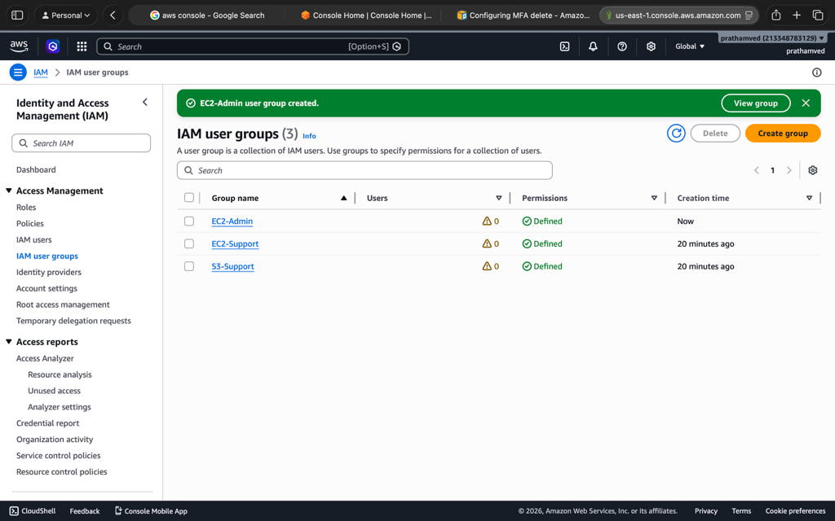

3.Create IAM users: user-1, user-2, and user-3
Navigate to IAM > Users > Create user.
- Create user-1, user-2, and user-3.
- Select AWS Management Console access.
- Set a custom password or use an autogenerated one.
- Do not add them to groups yet (we will do this in Step 5).

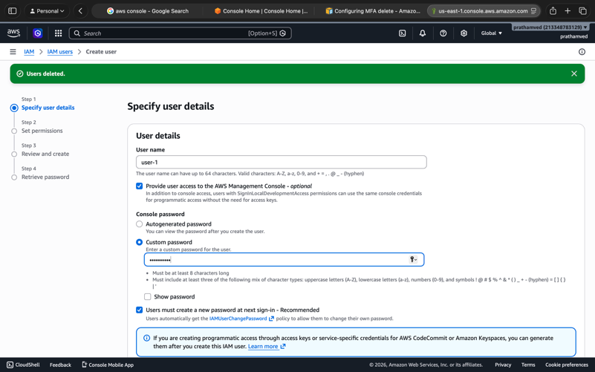
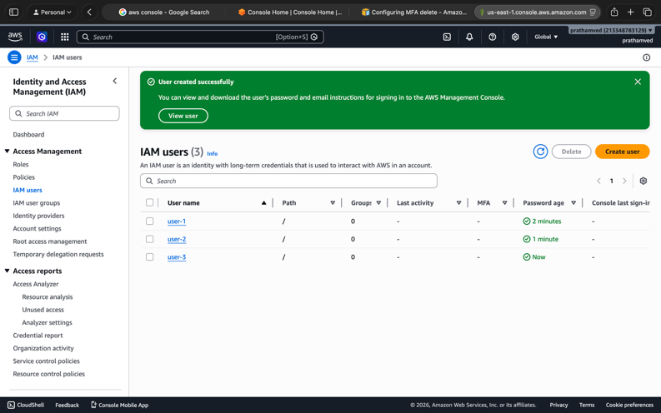

4.Implement Multi-Factor Authentication (MFA) for all users and enforce it
using an IAM policy.

Create the MFA Enforcement Policy
By default, "enforcing" MFA requires a custom JSON policy that denies actions if the user is not signed in with MFA.
- Go to IAM > Policies > Create Policy.
- Click the JSON tab and paste a policy that uses the aws:MultiFactorAuthPresent condition.
- Name it MFA-Enforcement-Policy.
Note: A standard enforcement policy effectively says: "Allow these actions only IF aws:MultiFactorAuthPresent is true; otherwise, Deny."
{
"Version": "2012-10-17",
"Statement": [
{
"Sid": "AllowUserToManageTheirOwnMFA",
"Effect": "Allow",
"Action": [
"iam:CreateVirtualMFADevice",
"iam:EnableMFADevice",
"iam:ListVirtualMFADevices",
"iam:ResyncMFADevice"
],
"Resource": [
"arn:aws:iam::*:mfa/${aws:username}",
"arn:aws:iam::*:user/${aws:username}"
]
},
{
"Sid": "DenyEverythingIfNoMFA",
"Effect": "Deny",
"NotAction": [
"iam:CreateVirtualMFADevice",
"iam:EnableMFADevice",
"iam:ListVirtualMFADevices",
"sts:GetSessionToken"
],
"Resource": "*",
"Condition": {
"BoolIfExists": { "aws:MultiFactorAuthPresent": "false" }
}
}
]
}
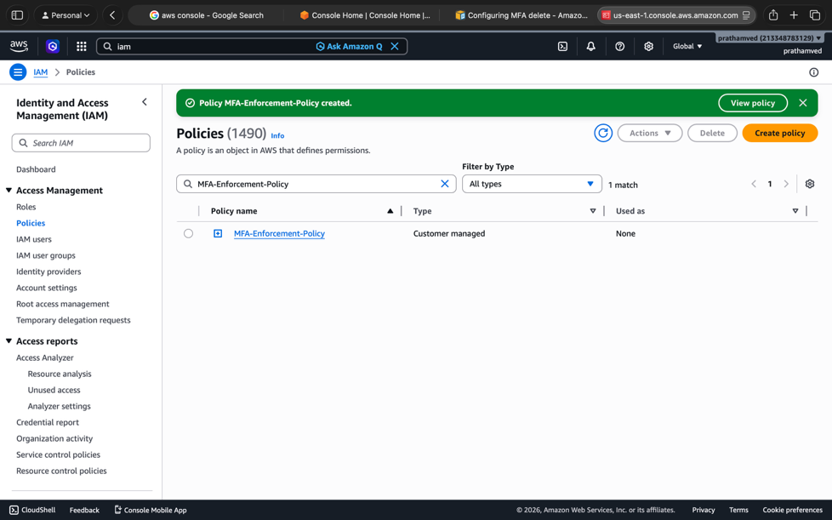

5.Assign each user to the corresponding group.
Navigate to IAM > Groups and add the users to their respective buckets:
- S3-Support: Add user-1
- EC2-Support: Add user-2
- EC2-Admin: Add user-3
- All Groups: Attach the MFA-Enforcement-Policy (created in Step 3) to every group or directly to the users.

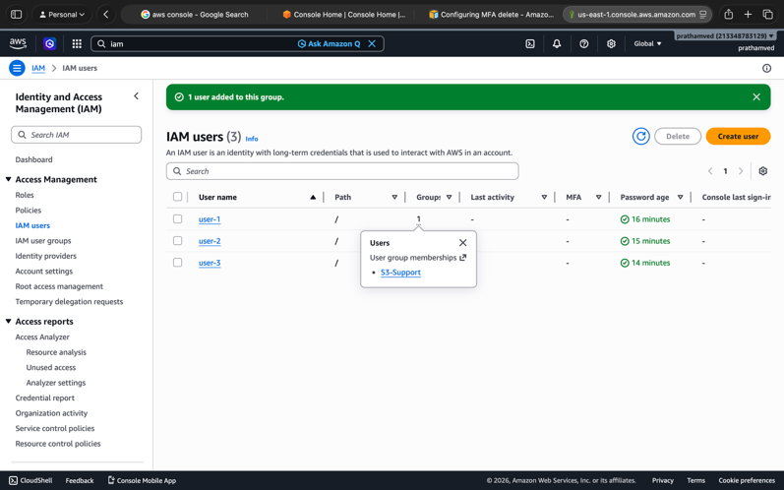

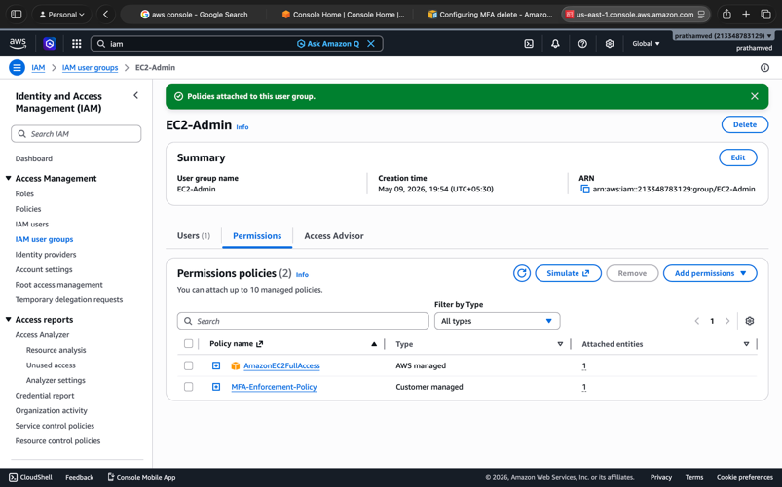
All Groups: Attach the MFA-Enforcement-Policy (created in Step 3) to every group or directly to the users

6.Verify that permissions are correctly applied by testing access levels.|
user-1
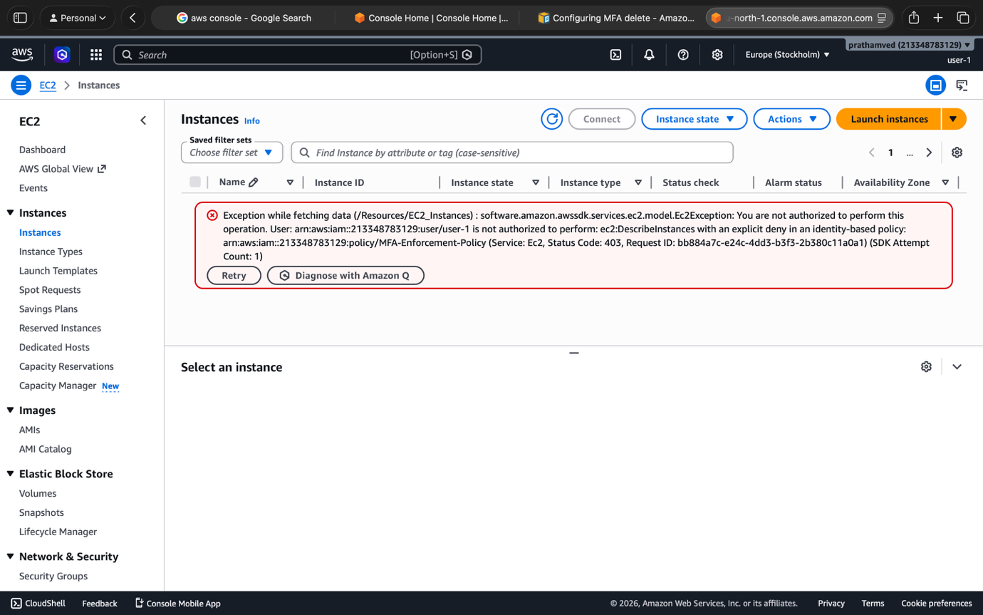
User | Expected Result
user-1 | Can view S3 buckets; cannot start/stop EC2.
user-2 | Can view EC2 instances; cannot start/stop them.
user-3 | Can View, Start, and Stop EC2 instances.
All Users | If logged in without MFA, they should be denied access to everything (due to the enforcement policy).
Q2. Using Amazon Web Services, demonstrate storage provisioning, backup, and data
recovery using Amazon EBS with Amazon EC2.
This is a classic disaster recovery lab for your practicals. Since you are already working with EC2-Admin (user-3), you have the full permissions needed to handle EBS volumes and snapshots.
Follow these steps to complete the storage and backup lifecycle:

Step 1: Create an Amazon EBS Volume
- Go to the EC2 Dashboard.
- In the left menu, under Elastic Block Store, select Volumes.
- Click Create volume.
- Important: Ensure the Availability Zone matches exactly where your EC2 instance is running (e.g., us-east-1a).
- Set size (e.g., 1 GiB) and click Create volume.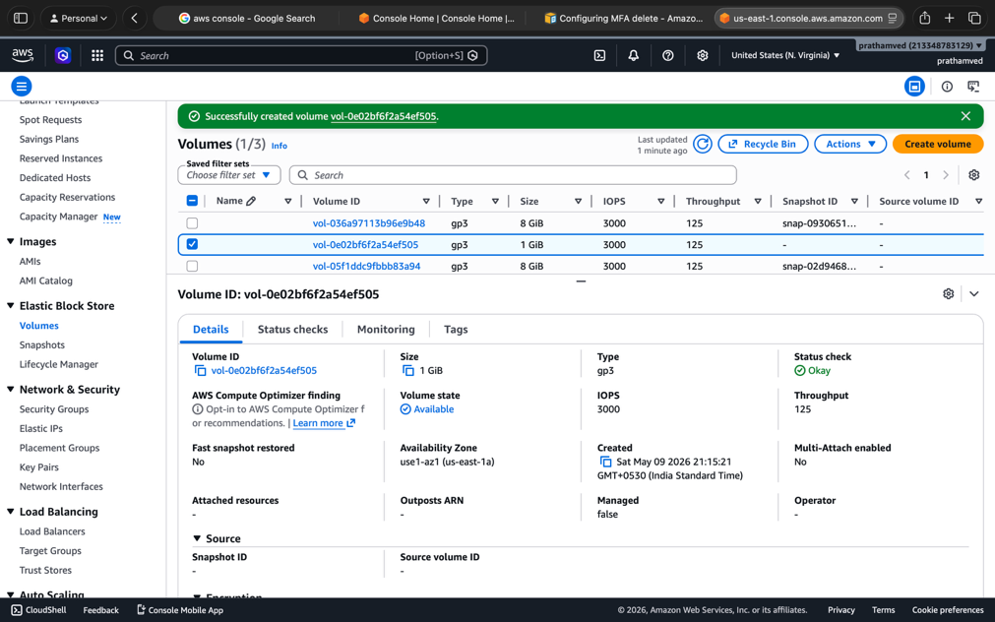

Step 2: Attach to EC2 Instance
- Select your new volume, click Actions, and choose Attach volume.
- Select your running EC2 instance.
Note the device name (usually /dev/sdf or /dev/xvdf). Click Attach.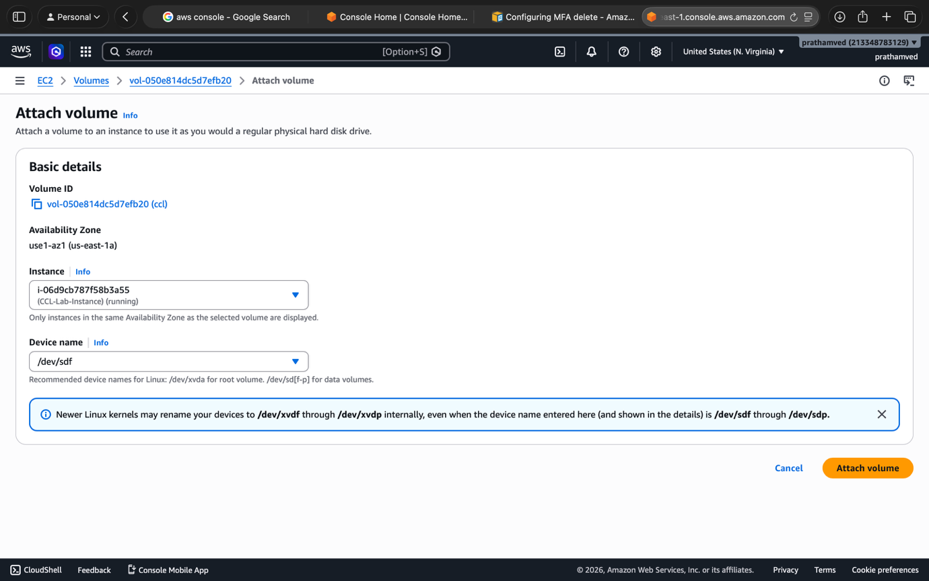

Step 3: Configure and Mount the File System
Connect to your instance via SSH or EC2 Instance Connect and run these commands: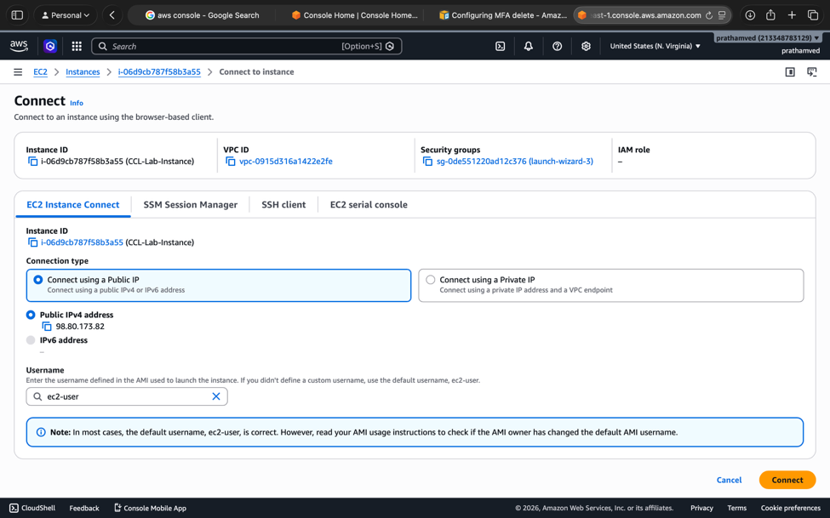
- Check the disk: lsblk (You should see your 1GB disk listed).
- Create file system: sudo mkfs -t ext4 /dev/xvdf
- Create mount point: sudo mkdir /mnt/my-data
- Mount it: sudo mount /dev/xvdf /mnt/my-data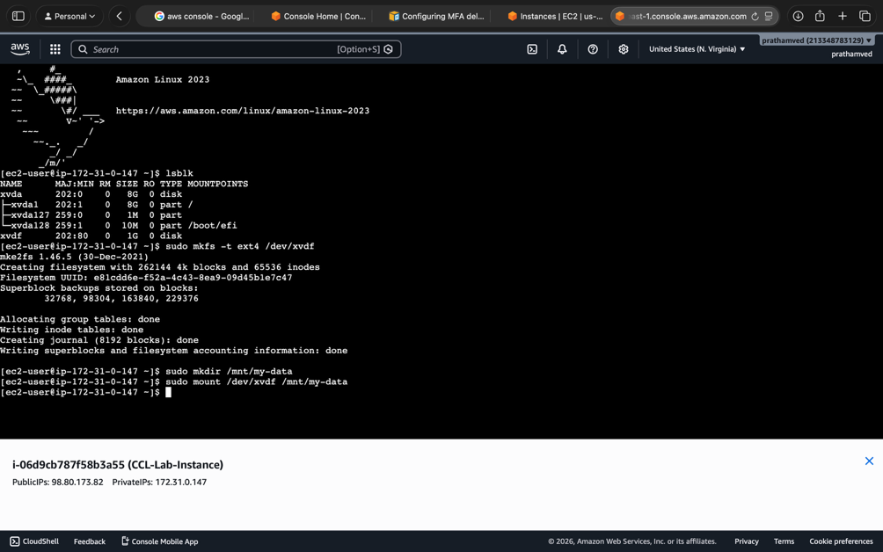

Step 4: Store Sample Data
- Create a file: echo "This is my backup test" | sudo tee /mnt/my-data/testfile.txt
- Verify: ls /mnt/my-data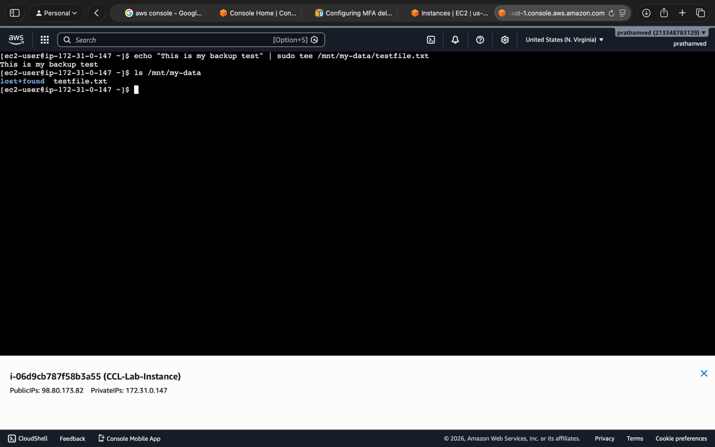

Step 5: Create EBS Snapshot (Backup)
- Go back to the Volumes screen in the AWS Console.
- Select your volume -> Actions -> Create snapshot.
- Add a description like "Lab Backup" and click Create snapshot.
- Wait for the status in the Snapshots menu to show Completed.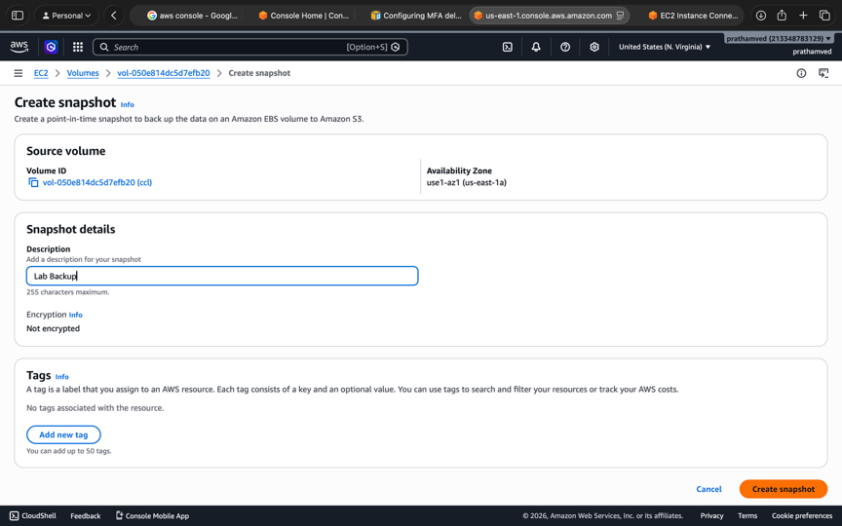

Step 6: Restore Data (Create New Volume)
- In the Snapshots menu, select your snapshot.
- Click Actions -> Create volume from snapshot.
- Again, ensure the Availability Zone matches your EC2 instance. Click Create volume
.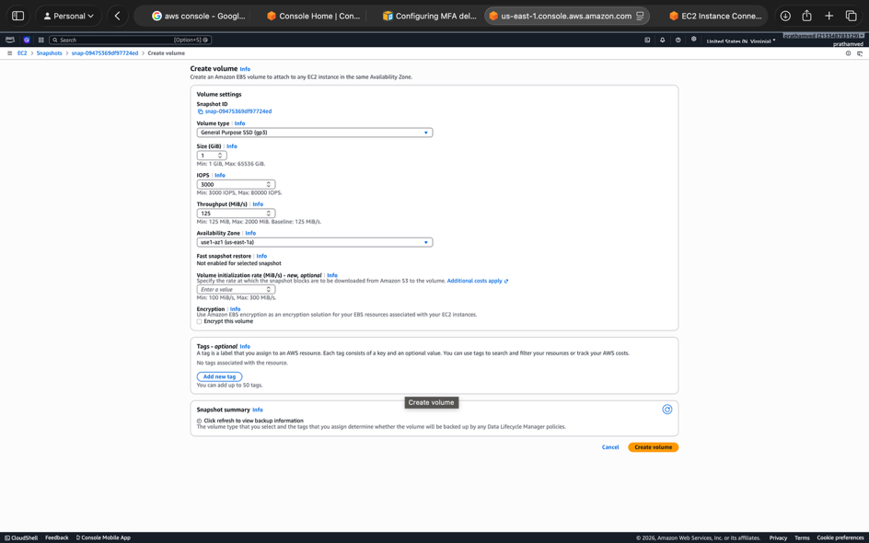

Step 7: Attach Restored Volume
- Go to Volumes, select the new volume you just created from the snapshot.
- Click Actions -> Attach volume and pick the same EC2 instance.
  - Note: It will use a different device name (e.g., /dev/sdg).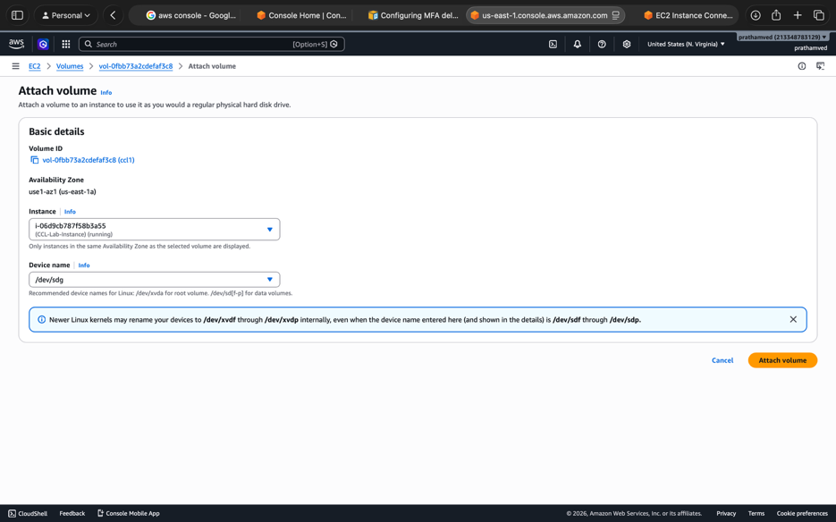

Step 8: Mount and Verify Recovery
Back in your terminal:
- Create a new mount point: sudo mkdir /mnt/recovered-data
- Mount the restored disk: sudo mount /dev/xvdg /mnt/recovered-data
  - Note: You don't need mkfs here because the data is already there!
- The Final Check: cat /mnt/recovered-data/testfile.txt
If you see "This is my backup test," your data recovery is successful!
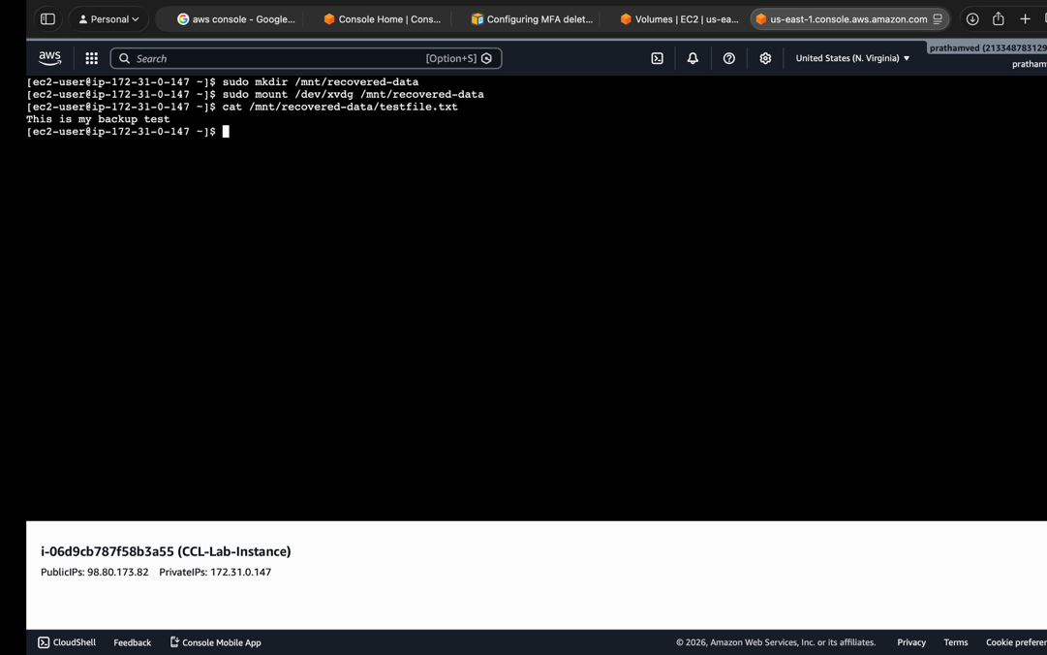

Q3 To Store and retrieve files using AWS S3

Task

Step 1: Open Amazon S3
- Log in to the AWS Management Console.
- In the search bar at the top, type S3 and select it from the services list.

Step 2: Create a New S3 Bucket
- Click the orange Create bucket button.
- Bucket name: Enter a unique name (e.g., ccl-practical-yourname-2026). Bucket names must be globally unique across all of AWS.
- Region: Keep the default (e.g., us-east-1).
- Object Ownership: Keep "ACLs disabled" (recommended) or "ACLs enabled" if your lab specifically requires older access methods.
- Block Public Access settings: For this specific lab (Task 4), you must uncheck the box that says "Block all public access."
  - Note: You will have to check a box acknowledging that this makes the bucket potentially public.
- Click Create bucket.
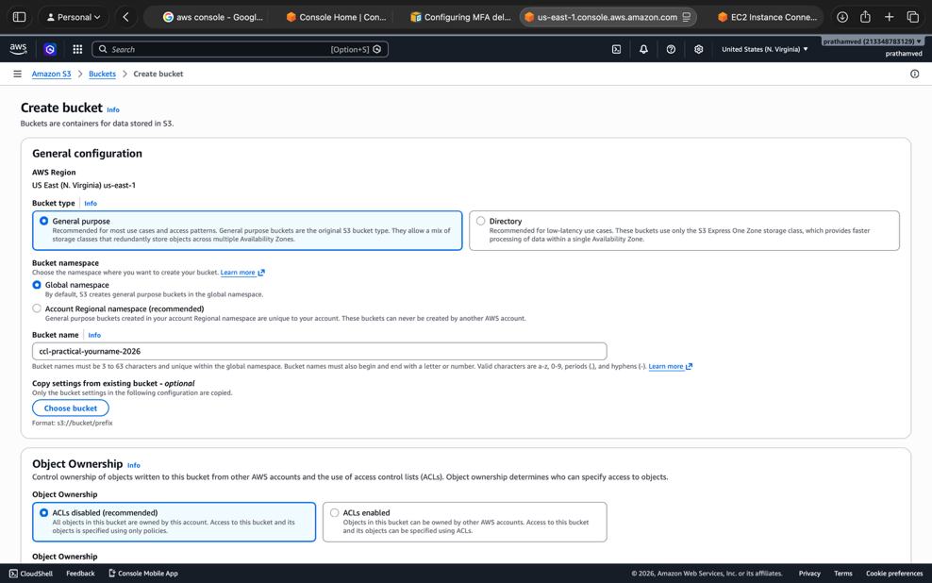

Step 3: Upload Files
- Click on the name of your newly created bucket.
- Click Upload -> Add files.
- Select a text document and an image from your computer.
- Click the orange Upload button at the bottom.

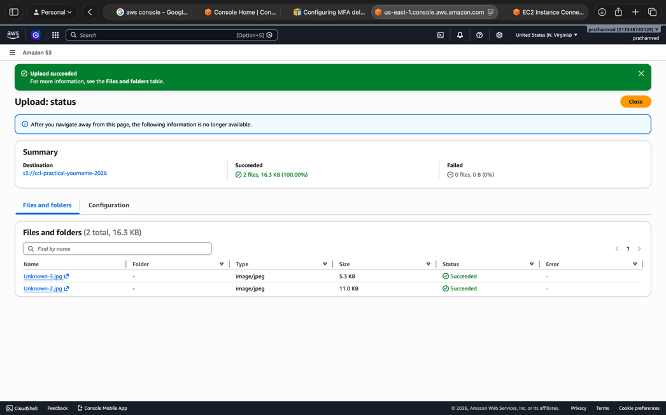
4.Configure public access permissions for uploaded files.

Step 4: Configure Public Access Permissions
By default, even if the bucket allows public access, individual files are private. To make them viewable via URL:
- Bucket Policy (The easiest way):
  - Go to the Permissions tab of your bucket.
  - Scroll down to Bucket policy and click Edit.
  - Paste this policy (replace YOUR-BUCKET-NAME with your actual bucket name):
JSON
{
"Version": "2012-10-17",
"Statement": [
{
"Sid": "PublicReadGetObject",
"Effect": "Allow",
"Principal": "*",
"Action": "s3:GetObject",
"Resource": "arn:aws:s3:::ccl-practical-yourname-2026/*"
}
]
}
- Click Save changes.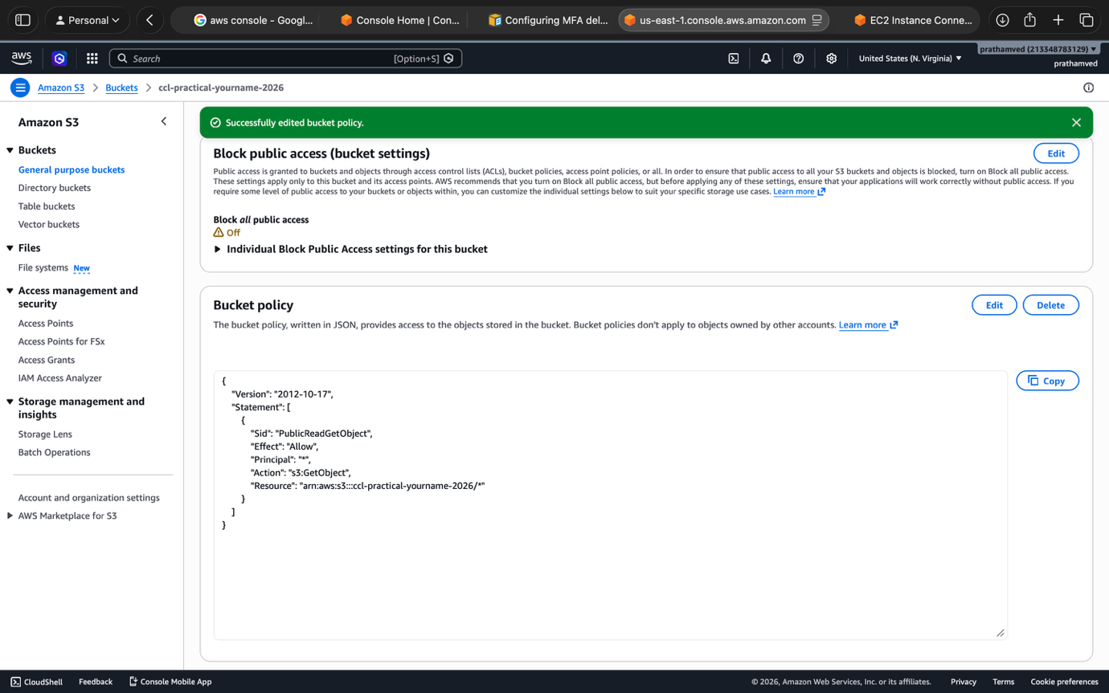

Step 5: Access and Verify via URL
- Go back to the Objects tab.
- Click on the name of one of the files you uploaded (e.g., image.jpg).
- Find the Object URL (usually looks like [https://bucket-name.s3.amazonaws.com/filename](https://bucket-name.s3.amazonaws.com/filename)).
- Copy the URL and paste it into a new Incognito/Private browser window.
- If the file opens or downloads, you have successfully completed the task!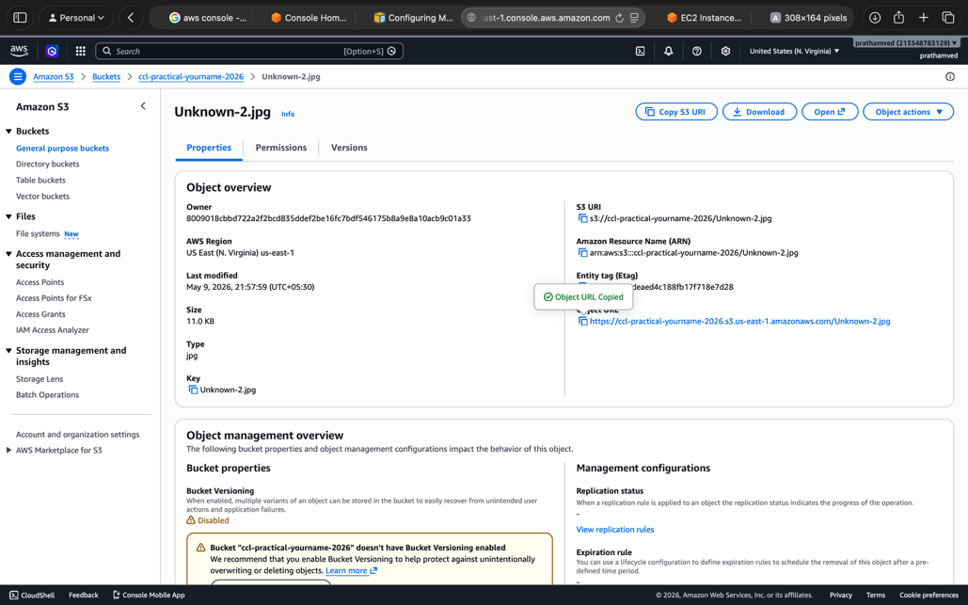

Q4 Using Amazon Web Services, create and configure a relational database instance using
Amazon RDS.

Step 1: Open Amazon RDS
- Log in to the AWS Management Console.
- Search for RDS and select it from the services list.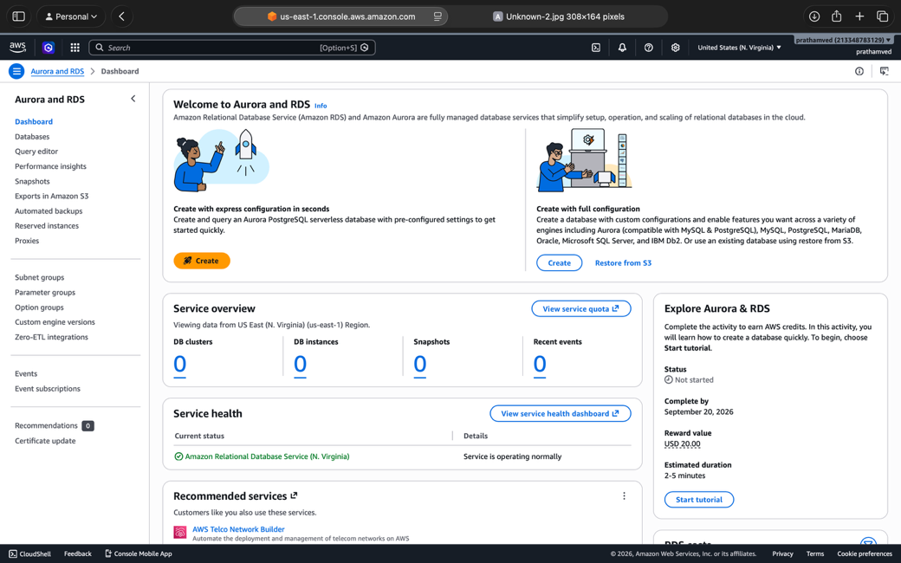

Step 2 & 3: Create Database (Standard Create & Engine)
- Click Create database.
- Choose Full configuration create (do not use "Easy create").
- Engine options: Select MySQL (this is usually easiest for practicals).
- Templates: Select Free Tier. This is crucial—it will automatically disable expensive options.

Step 4 & 5: Configure Instance & Credentials

Once you click "Full configuration", follow these exact steps:
- Engine Options: Choose MySQL.
- Templates: Select Free Tier (this simplifies the rest of the options for you).
- Settings (Task 5):
  - Set Master username (e.g., admin).
  - Set Master password (e.g., CclLab123).
- Instance configuration (Task 4): Ensure it is set to
db.t3.micro (Standard Free Tier)

Step 6: Storage (Free Tier Limits)
- Allocated storage: Set this to 20 GiB (the Free Tier limit).
- Storage autoscaling: Uncheck "Enable storage autoscaling" to stay strictly within limits.

Step 7: Connectivity (Public Access)
- Public access: Select Yes. (This is required for Task 7 and 9).
- VPC security group: Choose Create new.
- New VPC security group name: ccl-rds-sg.
- Database port: Keep default 3306.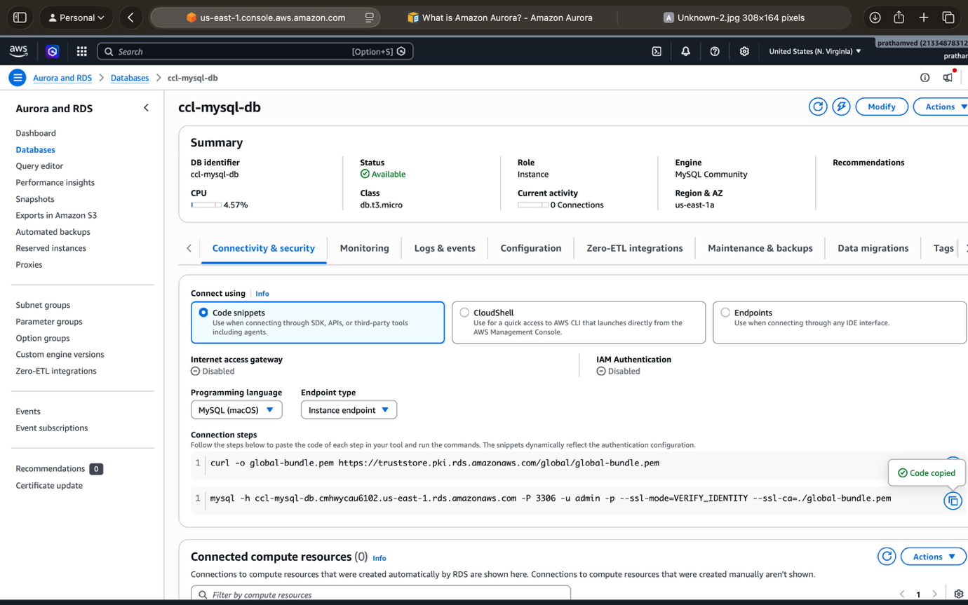

Step 8: Automatic Backups
- Expand the Additional configuration section at the bottom.
- Under Backup, ensure Enable automatic backups is checked.
- Set the Backup retention period to 1 day (the minimum for the lab).
- Click Create database.
  - Note: It takes about 5–10 minutes for the status to change from "Creating" to "Available."

Step 9: Connect to the Database
To connect from your computer (MySQL Workbench):
- Click on your database name in the RDS console.
- Copy the Endpoint (it looks like ccl-mysql-db.xxxx.us-east-1.rds.amazonaws.com).
- Important Security Step:
  - Click on your VPC security group (under the Connectivity tab).
  - Edit Inbound rules.
  - Add a rule: Type: MySQL/Aurora | Port: 3306 | Source: My IP.
  - Click Save rules.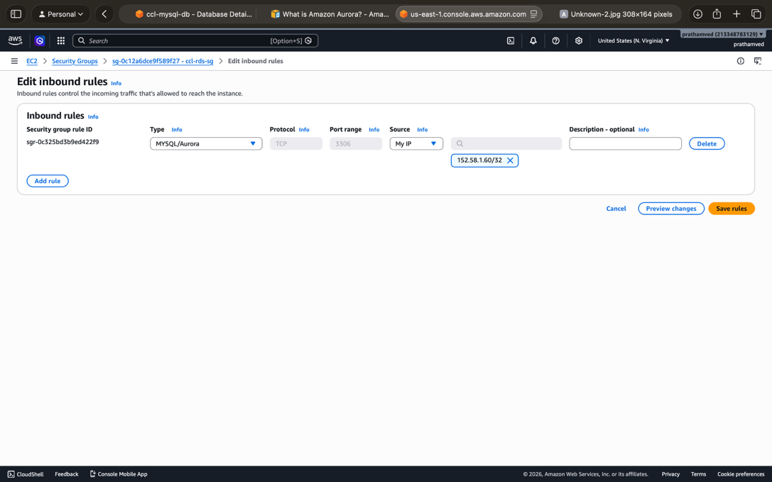
- In MySQL Workbench: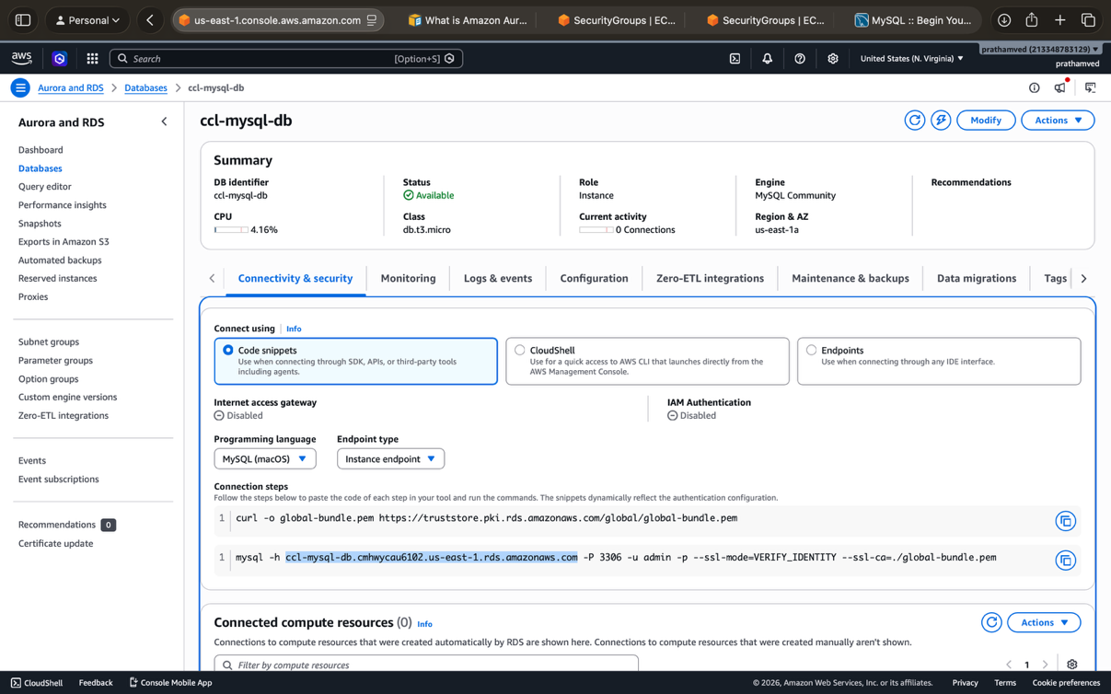

1. Fill in the Details
- Connection Name: Type AWS-Practical.
- Hostname: Delete 127.0.0.1 and paste your RDS Endpoint.
  - It should look something like: ccl-mysql-db.xxxx.us-east-1.rds.amazonaws.com.
- Username: Change root to admin.
- Password: Click Store in Keychain... and type the password you set during the RDS creation (the one you used in Step 5).
- Default Schema: Leave this blank for now.
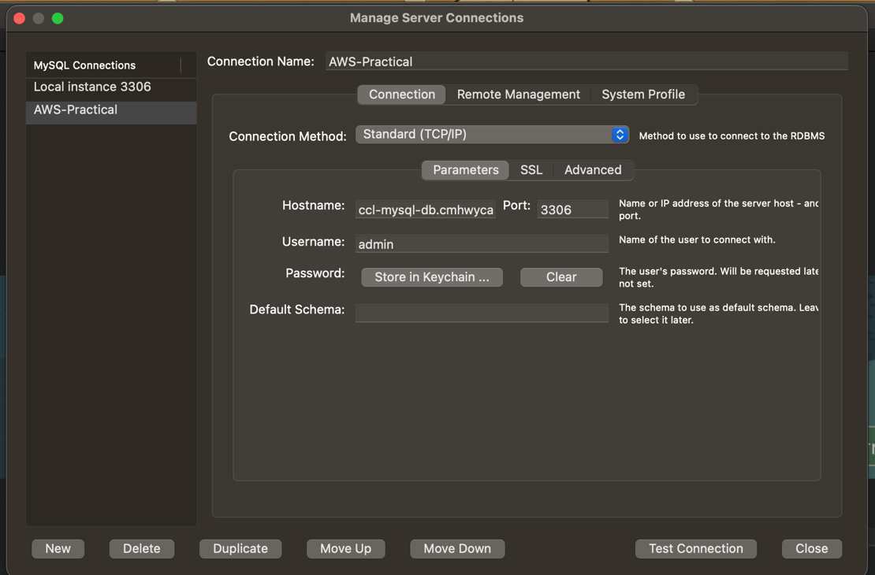

Step 10: Verify Connectivity
Once connected, run these SQL commands:
SQL
-- Create a sample table
CREATE DATABASE ccl_test;
USE ccl_test;

CREATE TABLE Students (
id INT PRIMARY KEY AUTO_INCREMENT,
name VARCHAR(50),
roll_no INT
);

-- Insert a record
INSERT INTO Students (name, roll_no) VALUES ('Pratham', 64);

-- Verify
SELECT * FROM Students;
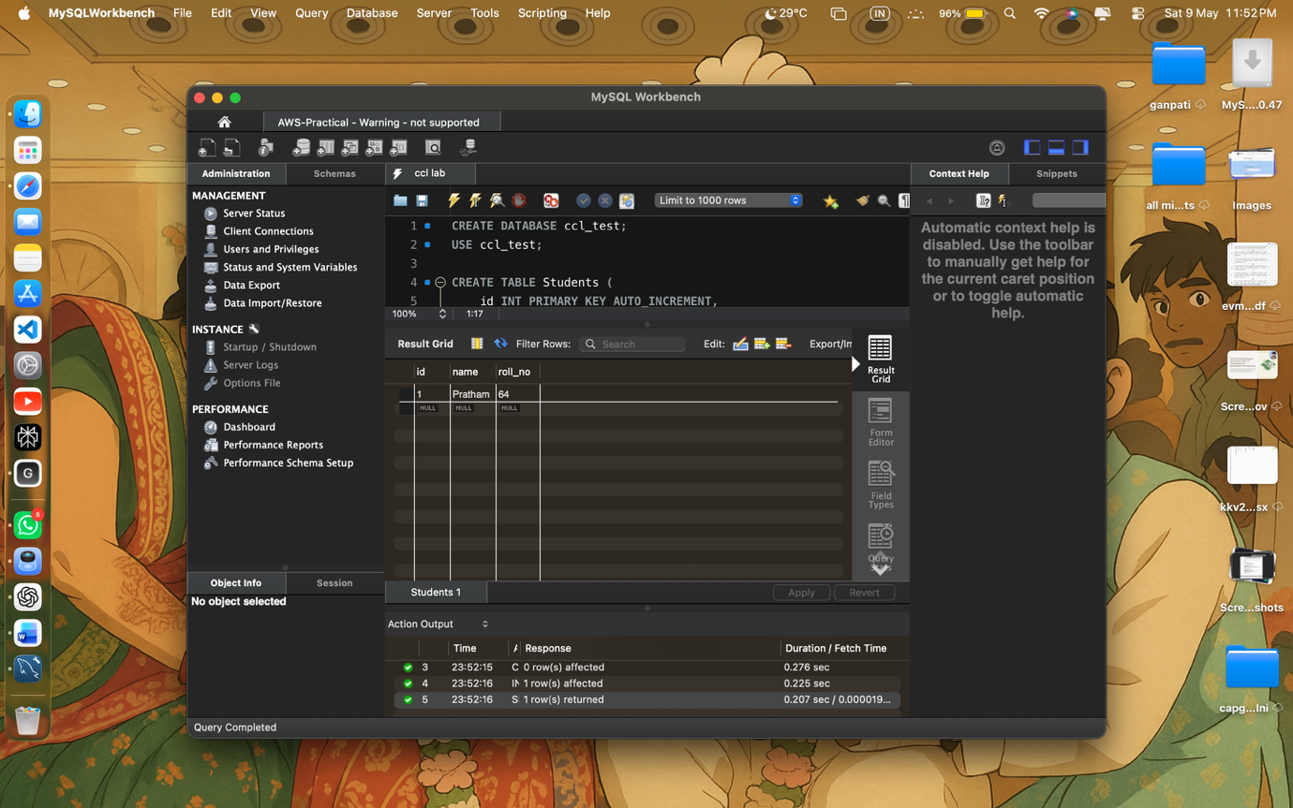

Q5 Using Amazon Web Services, create and deploy a simple static website using Amazon
S3.
Tasks to be Performed

Step 1 & 2: Create Bucket and Configure Hosting
- Open S3 and click Create bucket.
- Bucket name: Use something unique like my-static-site-pratham-64.
- Region: Keep it as us-east-1.
- Public Access: Uncheck "Block all public access" and acknowledge the warning.
- Create bucket.
- Click on your new bucket -> Properties tab.
- Scroll to the very bottom to Static website hosting and click Edit.
- Select Enable.
- Index document: Type index.html.
- Click Save changes.

Step 3: Prepare and Upload Files
On your computer, create a simple file named index.html using Notepad or VS Code:
HTML
<!DOCTYPE html>
<html>
<head>
<title>My AWS Website</title>
</head>
<body>
<h1>Welcome to my S3 Static Website</h1>
<p>This site is hosted on Amazon S3!</p>
<img src="my-image.jpg" alt="Lab Image" width="300">
</body>
</html>
- In the Objects tab of your bucket, click Upload.
- Add your index.html and an image file (make sure the image name matches exactly what you wrote in the code, e.g., my-image.jpg).
- Click Upload.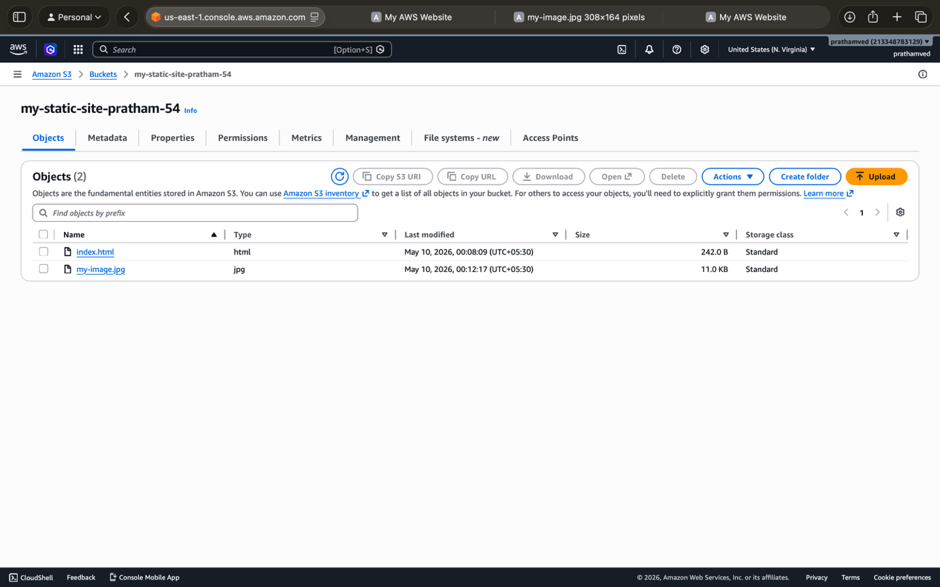

Step 4: Enable Public Access (Bucket Policy)
- Go to the Permissions tab.
- Scroll to Bucket policy and click Edit.
- Paste this JSON (replace YOUR-BUCKET-NAME with your actual bucket name):
JSON
{
"Version": "2012-10-17",
"Statement": [
{
"Sid": "PublicReadGetObject",
"Effect": "Allow",
"Principal": "*",
"Action": "s3:GetObject",
"Resource": "arn:aws:s3:::YOUR-BUCKET-NAME/*"
}
]
}
- Click Save changes.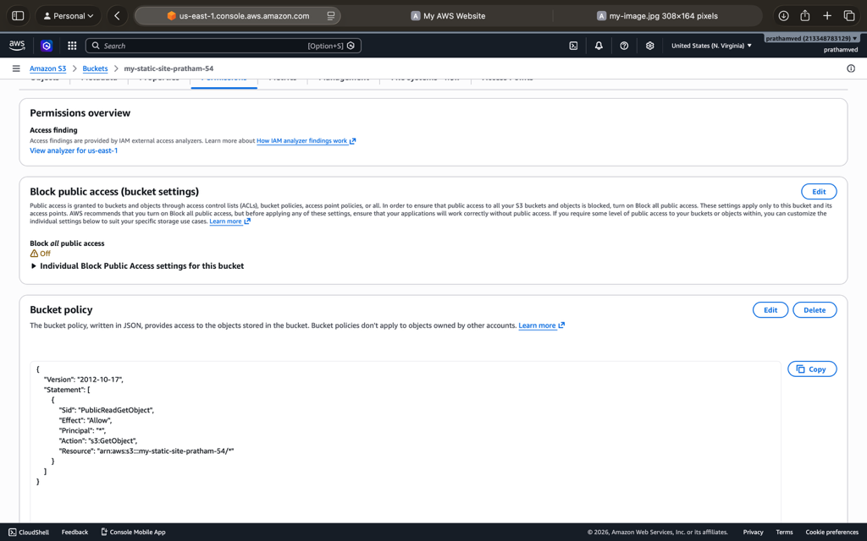

Step 5, 6 & 7: Access and Verify
- Go back to the Properties tab.
- Scroll to the bottom under Static website hosting.
- You will see a link called Bucket website endpoint. It looks like:
[http://your-bucket-name.s3-website-us-east-1.amazonaws.com](http://your-bucket-name.s3-website-us-east-1.amazonaws.com)
- Click the link.
- Your website should load showing your heading, text, and the image.
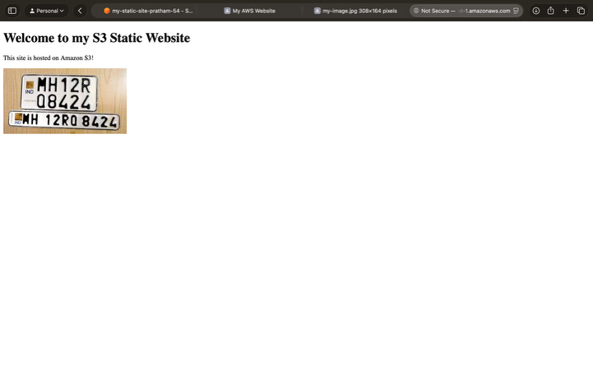

Step 1: Launch and Access CloudWatch
- Launch Instance: Ensure you have a running EC2 instance (Amazon Linux).
- Open CloudWatch: Search for CloudWatch in the AWS Console and open it.
- View Metrics: In the left menu, click Metrics -> All metrics.
- Find EC2 Data: Click on EC2 -> Per-Instance Metrics. Search for your Instance ID to see the specific graphs for your server.

Step 2: Monitor Key Metrics
Under the Graphed metrics tab, you can visualize the following as required by your task:
- CPUUtilization: Percentage of allocated compute power being used.
- DiskReadOps: Number of read operations from the EBS volume.
- NetworkIn / NetworkOut: Volume of traffic flowing into and out of the instance.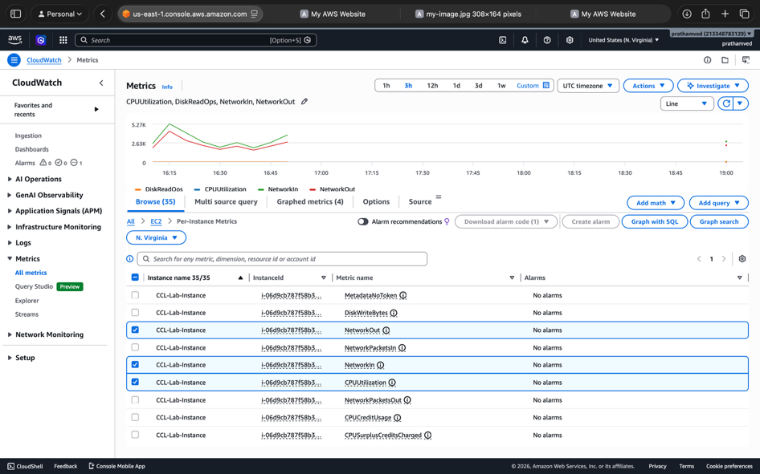

Step 3: Create a CloudWatch Alarm (70% CPU Trigger)
- In the CloudWatch left menu, click Alarms -> All alarms -> Create alarm.
- Click Select metric.
- Navigate to EC2 -> Per-Instance Metrics and check the box for your instance where the Metric Name is CPUUtilization. Click Select metric.
- Conditions:
  - Threshold type: Static.
  - Whenever CPUUtilization is...: Greater.
  - than...: 70.
- Click Next.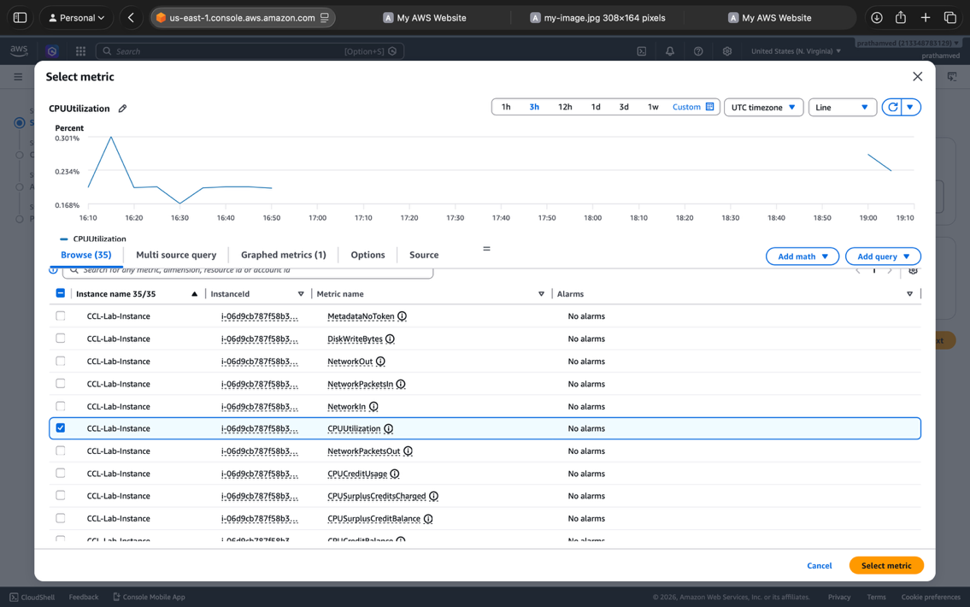

Step 4: Configure Notifications (SNS)
- Alarm state trigger: Select In alarm.
- Send a notification to the following SNS topic: Select Create new topic.
- Topic Name: CPU_Alert_Topic.
- Email endpoints: Enter your email address.
- Click Create topic.
  - Note: Check your email inbox and click "Confirm Subscription" in the email AWS sends you, therwise the alert won't reach you.
- Click Next, give the alarm a name (e.g., High-CPU-Alarm), and click Create alarm.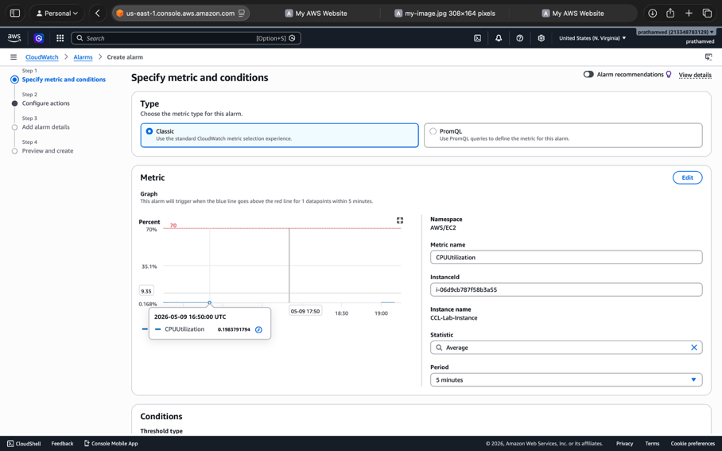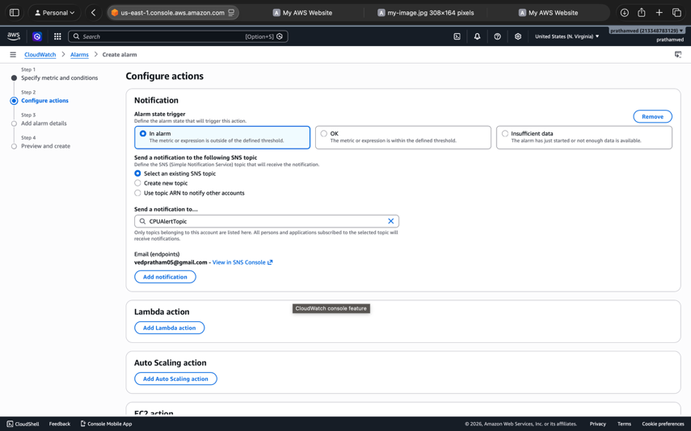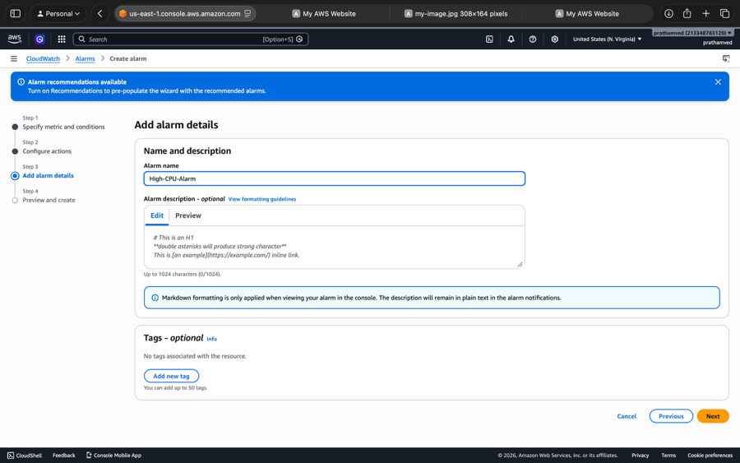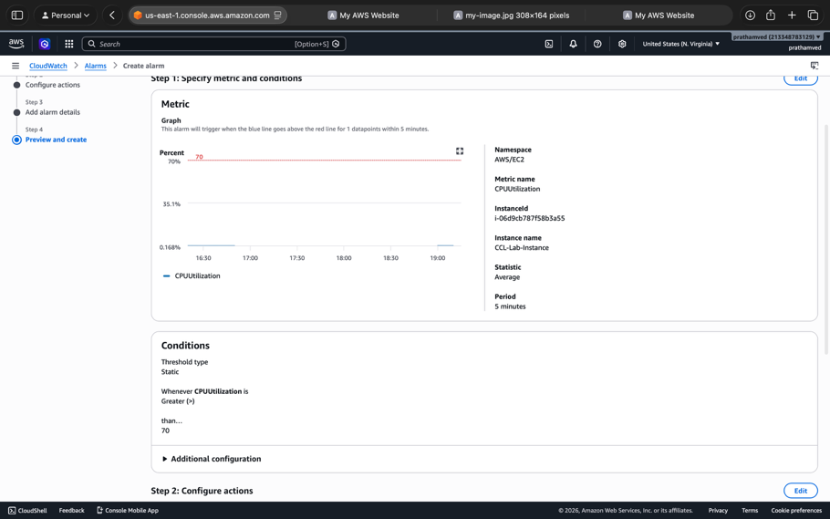

Step 5: Verify Alarm (Generate Load)

Connect to your Instance
- Go back to your EC2 Instances list.
- Select your running instance (i-06d9cb787f58b3a55).
- Click the Connect button at the top of the screen.
- Choose the EC2 Instance Connect tab.
- Click the orange Connect button at the bottom right. A new browser tab will open with a black terminal screen.
To verify the alarm, you need to connect to your instance using the terminal so you can run that stress command.

Step 1: Connect to your Instance
- Go back to your EC2 Instances list.
- Select your running instance (i-06d9cb787f58b3a55).
- Click the Connect button at the top of the screen.
- Choose the EC2 Instance Connect tab.
- Click the orange Connect button at the bottom right. A new browser tab will open with a black terminal screen.

Step 2: Run the Stress Command
In that black terminal screen, type the following and press Enter:
Bash
sha1sum /dev/zero &
- What this does: The & makes the command run in the background. It will start using 100% of one CPU core immediately.
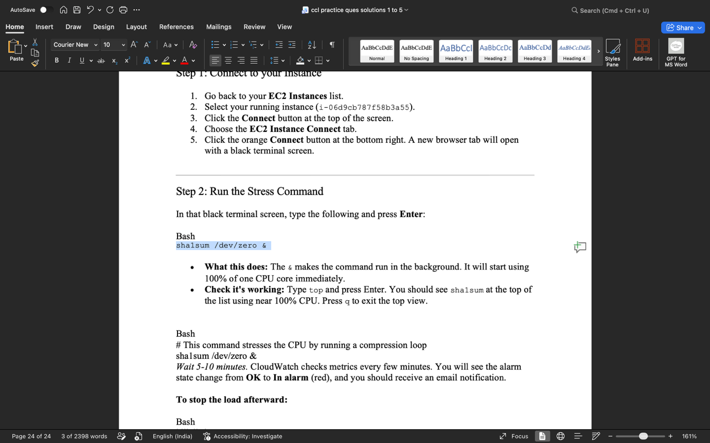
- Check it's working: Type top and press Enter. You should see sha1sum at the top of the list using near 100% CPU. Press q to exit the top view.
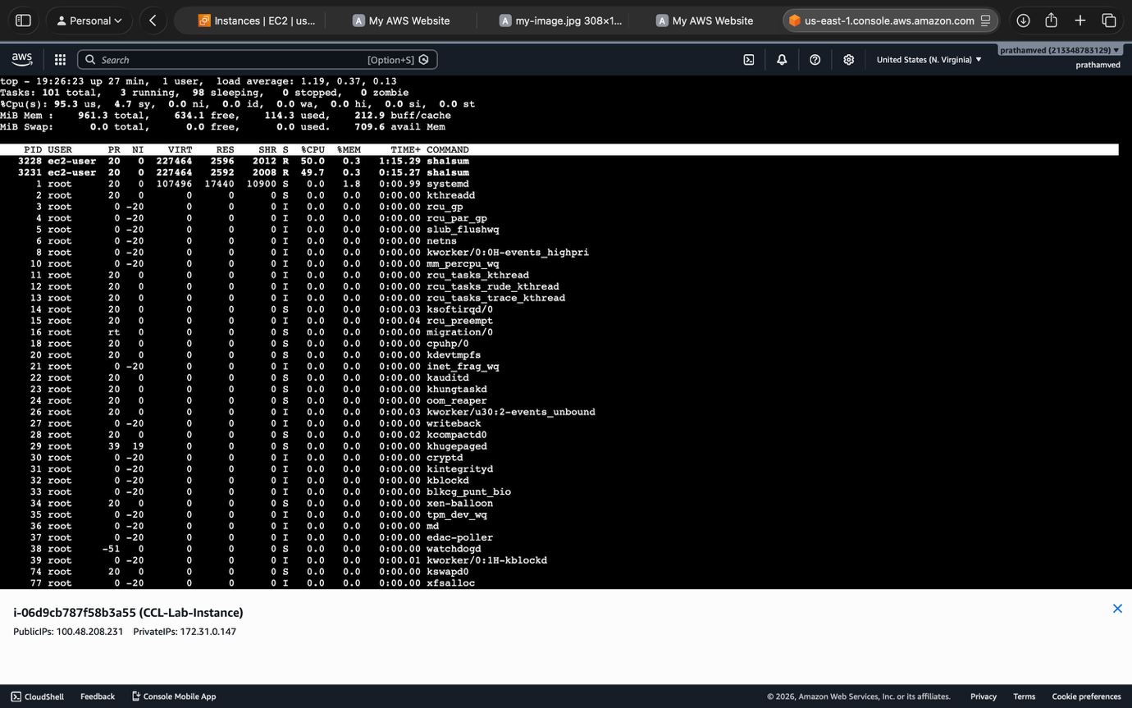
Bash
# This command stresses the CPU by running a compression loop
sha1sum /dev/zero &
Wait 5-10 minutes. CloudWatch checks metrics every few minutes. You will see the alarm state change from OK to In alarm (red), and you should receive an email notification.
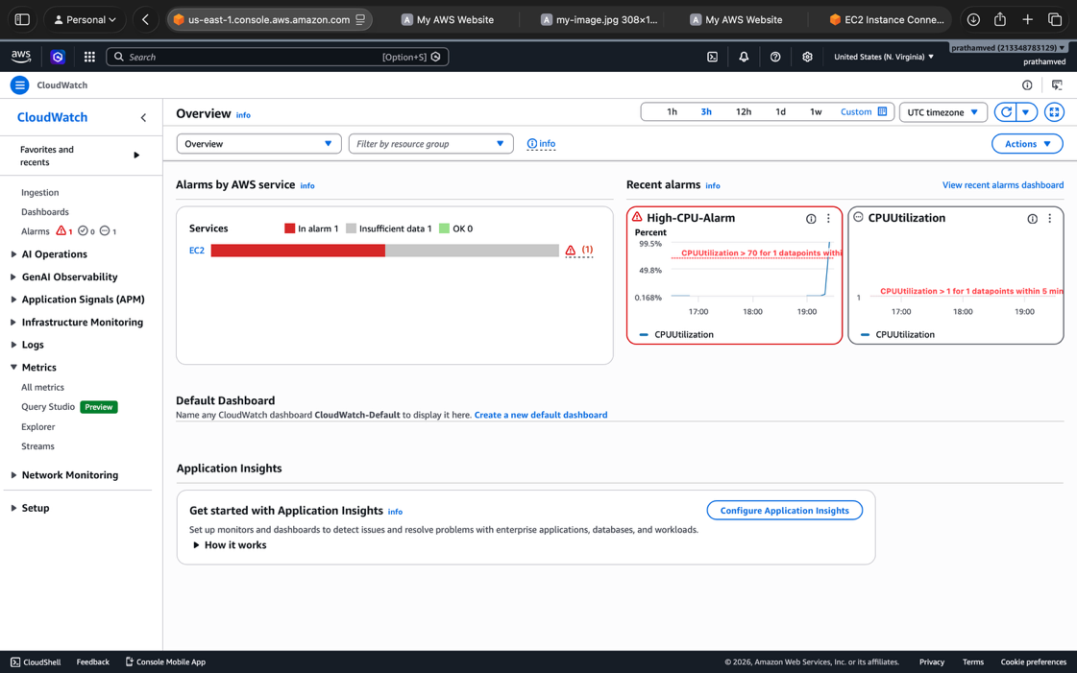

To stop the load afterward:
Bash
killall sha1sum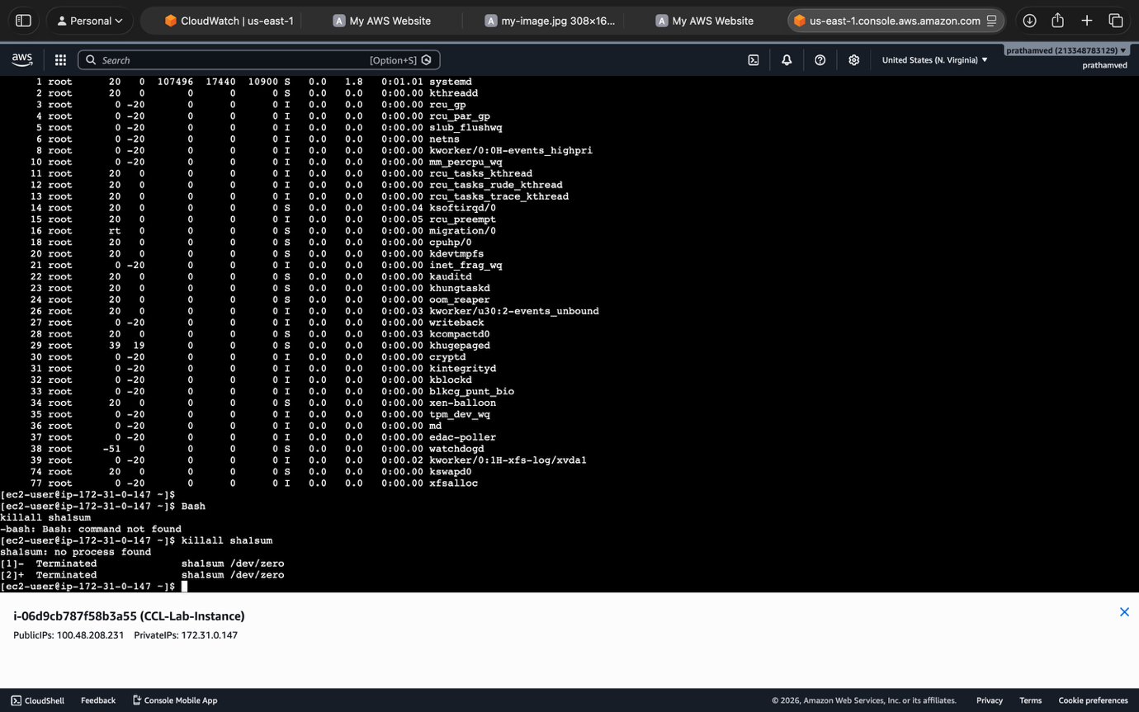

Q7

Since you have your CCL-Lab-Instance already running, you can actually use it to complete this final task. You’ve already done the hard part of connecting to the terminal; now you just need to turn it into a web server and handle the resizing.

Step 1: Use Your Existing Instance
You are already using an Amazon Linux instance (i-06d9cb787f58b3a55). Make sure it is in the Running state.

Step 2 & 3: Install and Start Apache
Connect to your instance via EC2 Instance Connect (the terminal you used for the stress test) and run these commands one by one:
Bash
# Update the package manager
sudo yum update -y

# Install Apache (httpd)
sudo yum install -y httpd
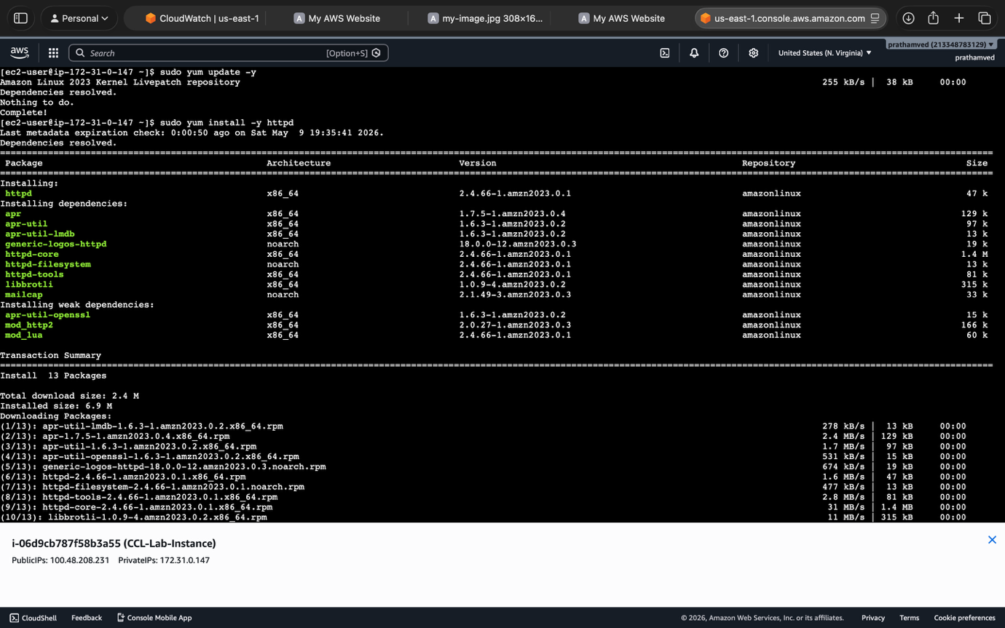

# Start the service
sudo systemctl start httpd

# Enable it to start automatically on reboot
sudo systemctl enable httpd

# Create a simple landing page
echo "<h1>Welcome to Pratham's EC2 Web Server</h1>" | sudo tee /var/www/html/index.html
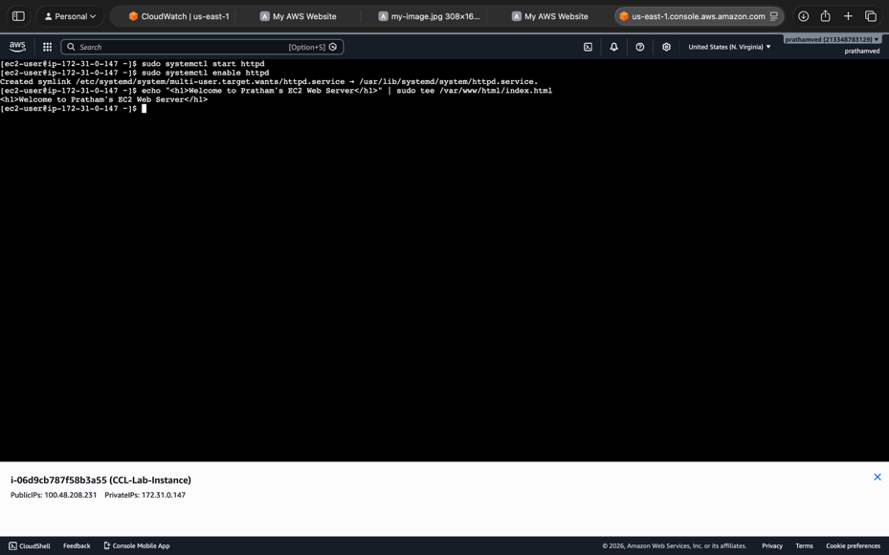

Step 4: Allow HTTP Access
You already know how to edit Security Groups!
- Go to your instance's Security Groups.
- Edit Inbound Rules.
- Add a new rule: Type: HTTP | Port: 80 | Source: Anywhere-IPv4 (0.0.0.0/0).
- Save rules.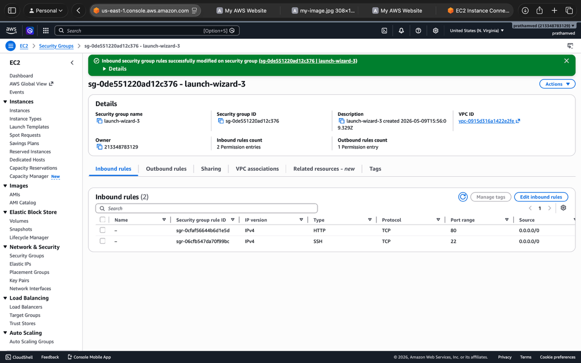

Step 5: Verify the Server
- Copy the Public IPv4 address of your instance (e.g., 100.48.208.231).
- Paste it into your browser's address bar.
- You should see your "Welcome" message.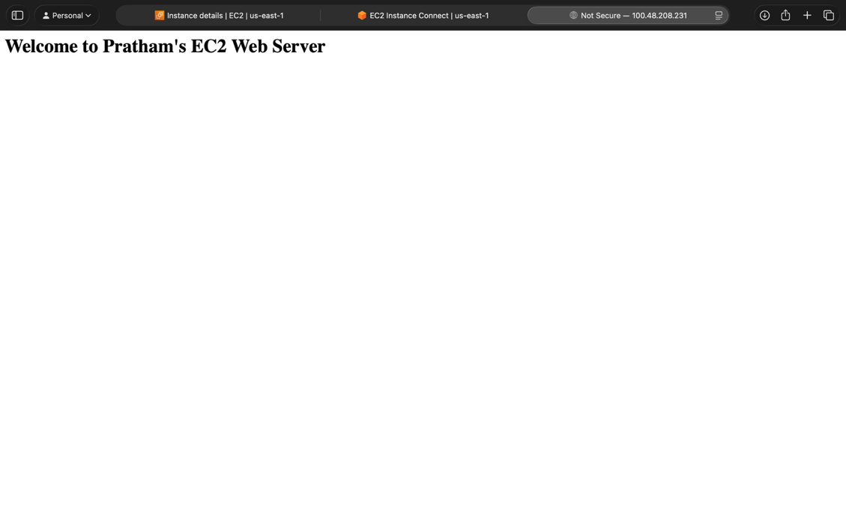

Step 6: Resize the Instance (The "Resource Modification" Part)
This is a two-part task that requires the instance to be Stopped first.

Part A: Changing Instance Type
- Go to the EC2 Dashboard and Stop your instance.
- Once stopped, click Actions -> Instance Settings -> Change instance type.
- Change it from t2.micro to t3.micro (or any other type allowed in your lab).
- Click Apply.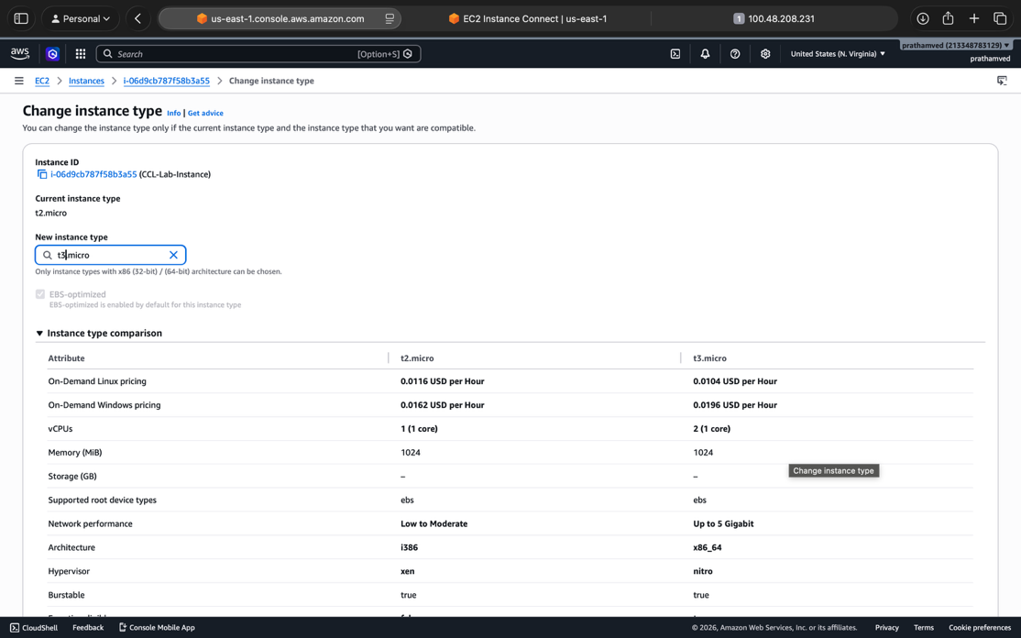

Part B: Modifying EBS Storage
- In the left menu, go to Elastic Block Store -> Volumes.
- Select the volume attached to your instance.
- Click Actions -> Modify volume.
- Change the Size (e.g., if it's 8 GiB, change it to 10 GiB).
- Click Modify and confirm.
- Go back to Instances and Start your instance again.

Q8
This is a more advanced networking task that builds on everything you've done tonight. It essentially asks you to build a small, secure data center in the cloud.

Step 1: Create the VPC with Subnets (The Network Foundation)
Instead of creating everything manually, the VPC Wizard is the fastest way to get this right for a lab.
- Search for VPC in the console.
- Click Create VPC.
- Select VPC and more (this creates your subnets, gateways, and routing in one go).
- Name tag: CCL-Custom-VPC.
- Availability Zones (AZs): Select 2.
- Number of Public Subnets: Select 2.
- Number of Private Subnets: Select 2.
- NAT Gateway: Select In 1 AZ (this allows private subnets to talk to the internet for updates, but stays hidden).
- Click Create VPC.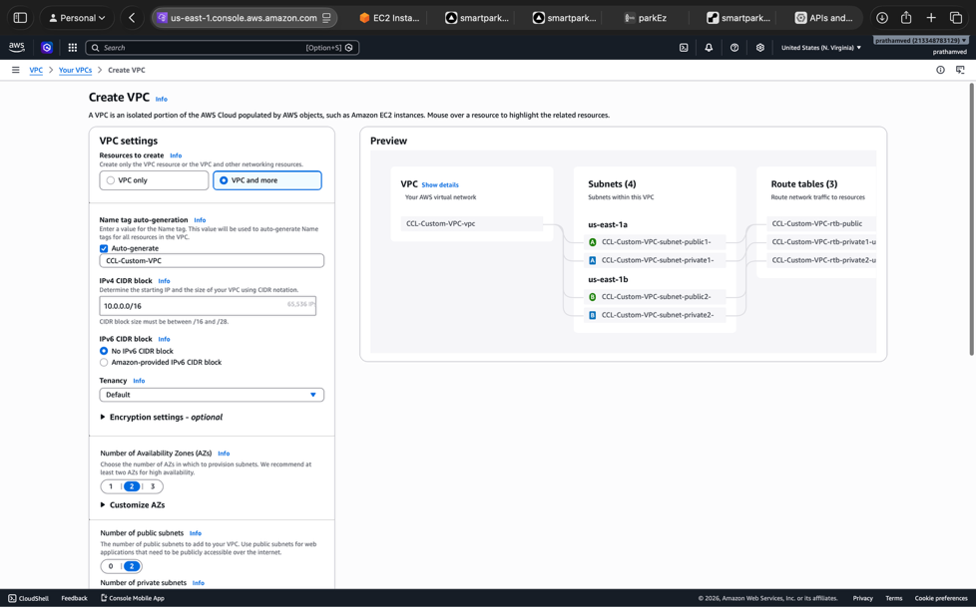

Step 2: Security Settings (The Firewalls)
You need a Security Group that specifically allows web traffic.
- In the VPC left menu, click Security Groups -> Create security group.
- Name: Web-Server-SG.
- VPC: Ensure you select your CCL-Custom-VPC.
- Inbound Rules:
  - Type: HTTP | Port: 80 | Source: 0.0.0.0/0
  - Type: SSH | Port: 22 | Source: My IP (for your own access).
- Click Create security group.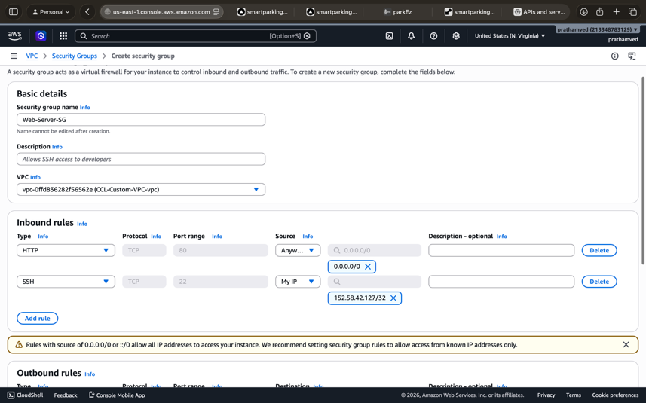

Step 3: Launch Web Server with User Data (Automation)
Instead of installing Apache manually like last time, we will use a User Data script to do it automatically during launch.
- Go to EC2 -> Launch instances.
- Name: VPC-Web-Server.
- AMI: Amazon Linux 2023.
- Network Settings (Click Edit):
  - VPC: Select CCL-Custom-VPC.
  - Subnet: Select a Public Subnet (important: must be Public!).
  - Auto-assign public IP: Select Enable.
  - Security Group: Select your existing Web-Server-SG.
- Advanced Details: Scroll to the very bottom to the User data box and paste this: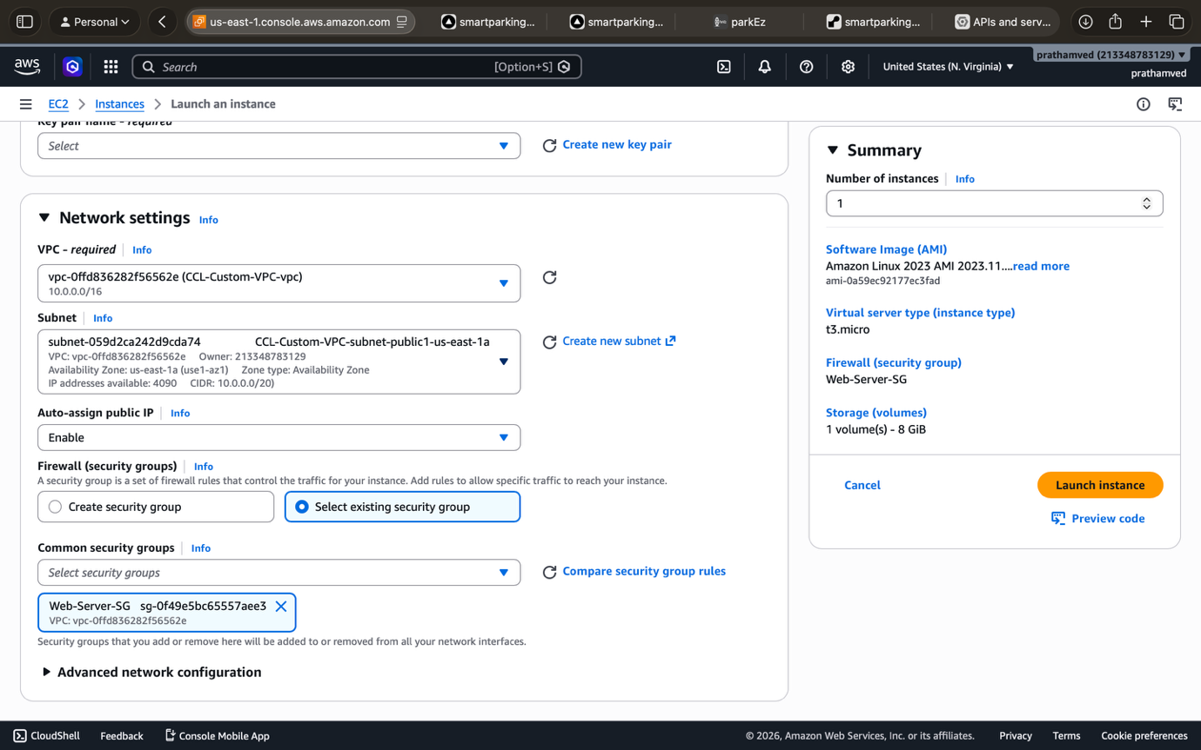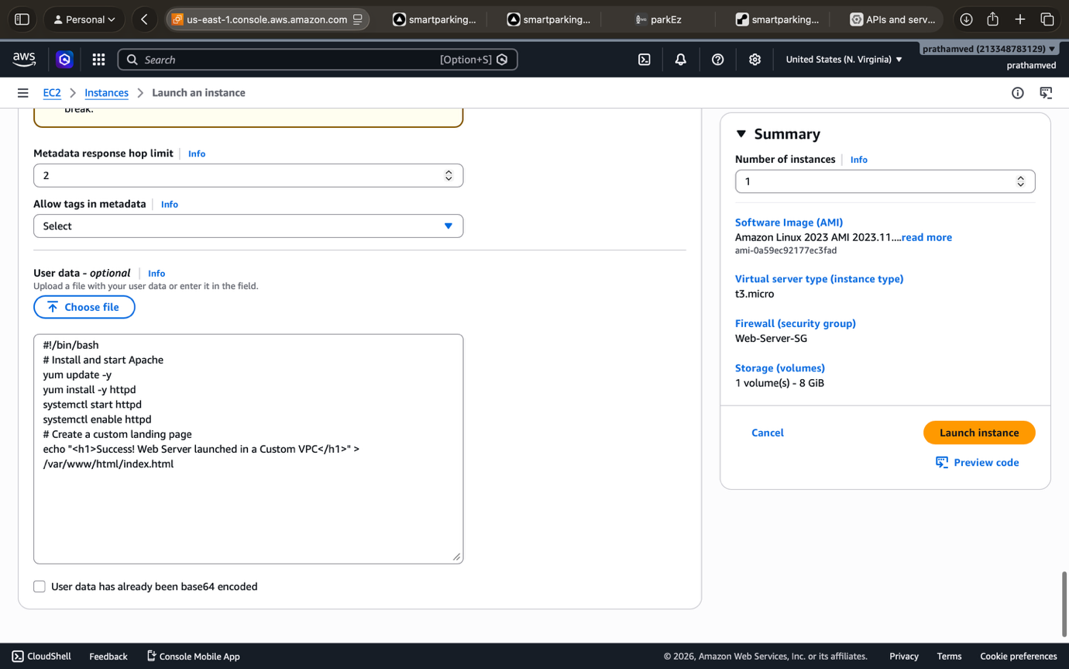
Bash
#!/bin/bash
# Install and start Apache
yum update -y
yum install -y httpd
systemctl start httpd
systemctl enable httpd
# Create a custom landing page
echo "<h1>Success! Web Server launched in a Custom VPC</h1>" > /var/www/html/index.html
- Click Launch instance.

Step 4: Verify Connectivity
- Wait for the instance Status Check to pass.
- Select the instance and copy the Public IPv4 DNS (e.g., ec2-xx-xx-xx.compute-1.amazonaws.com).
- Paste that address into your browser.
- If it loads, you have successfully configured:
  - Internet Gateway: Allowing traffic in.
  - Route Tables: Directing traffic to the public subnet.
  - Subnets: Separating public and private resources.
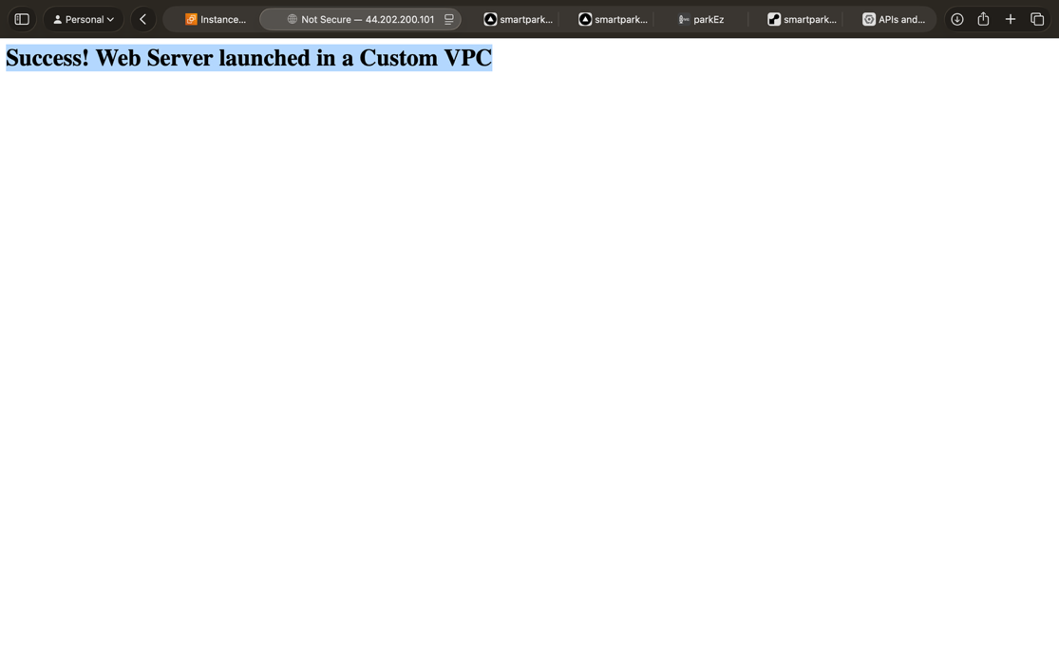

Q9
This is an essential task for Auditing and Security. CloudTrail acts like a "CCTV camera" for your AWS account, recording every click, command, and API call made by any user or service.

Step 1 & 2: Open CloudTrail and Create a Trail
- Search for CloudTrail in the AWS Management Console.
- Click Create trail.
- Trail name: Pratham-Activity-Log.
- Storage location: Select Create new S3 bucket.
- Trail Log Bucket and Folder: AWS will suggest a unique name like aws-cloudtrail-logs-213348783129-xxxx. Leave it as is.
- Apply trail to all regions: Ensure this is set to Yes. This ensures that even if someone launches an instance in London or Tokyo, it gets logged.
- Click Next, keep "Management events" checked, and click Next again to Create trail.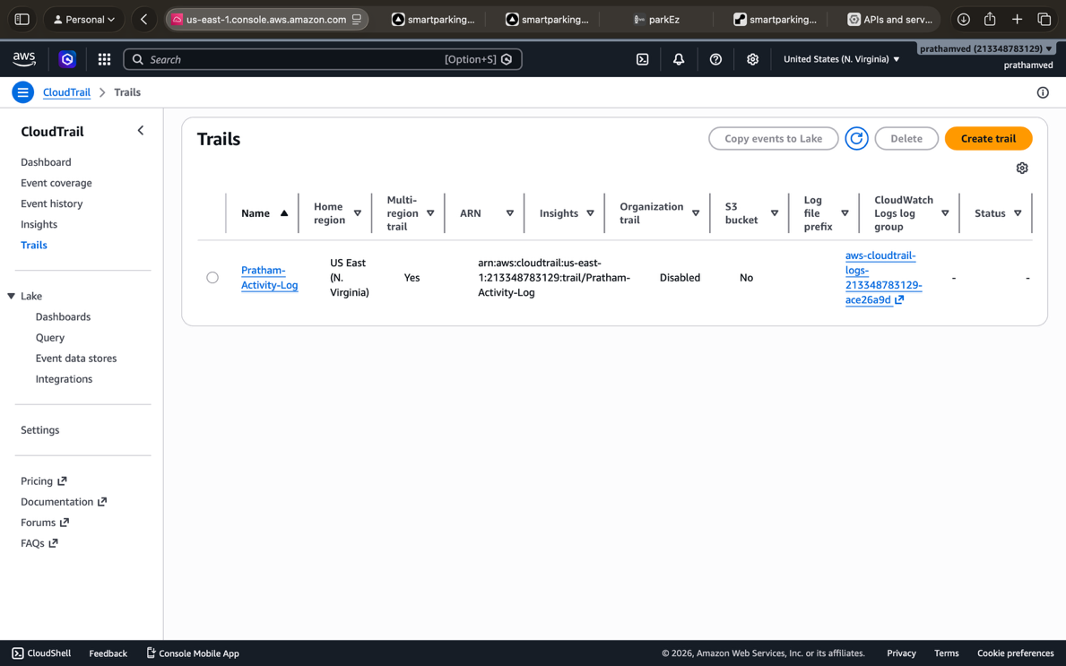

Step 3: The S3 Bucket (Verification)
AWS actually creates the S3 bucket for you during Step 2.
- Go to the S3 Console.
- Search for the bucket name you just saw in the CloudTrail setup.
- Open the bucket. You will see a folder structure like AWSLogs/AccountID/CloudTrail/.
  - Note: It may be empty for a few minutes; logs take a bit of time to "deliver" to S3.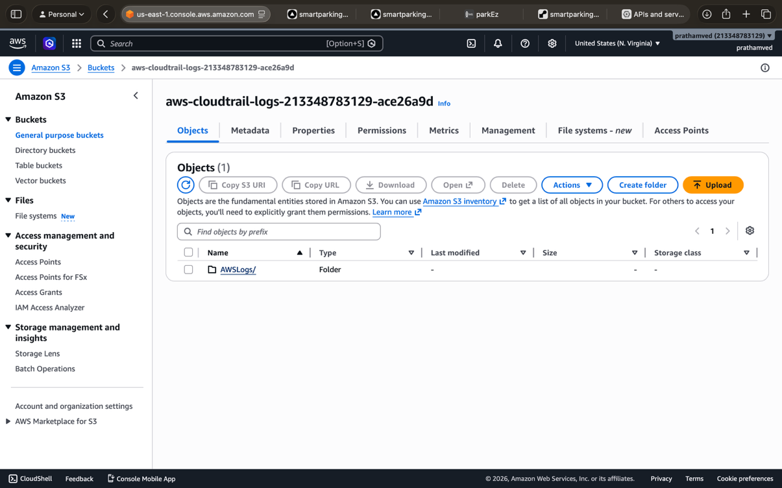

Step 4: Perform an AWS Action (The Trigger)
To test if it's working, we need to create a "paper trail":
- Go to the EC2 Dashboard.
- Select your VPC-Web-Server (or any instance).
- Click Instance state -> Stop instance.
- Once it stops, click Instance state -> Start instance.

Step 5: Verify the Log (The Evidence)
CloudTrail has two places to check: the Event History (fastest) and the S3 Bucket (permanent storage).
Checking Event History (Immediate):
- Go back to the CloudTrail Dashboard.
- Click Event history in the left menu.
- Look for events like:
  - StopInstances
  - StartInstances
- Click on the event name. You will see exactly who did it (your username), when, and from which IP address.
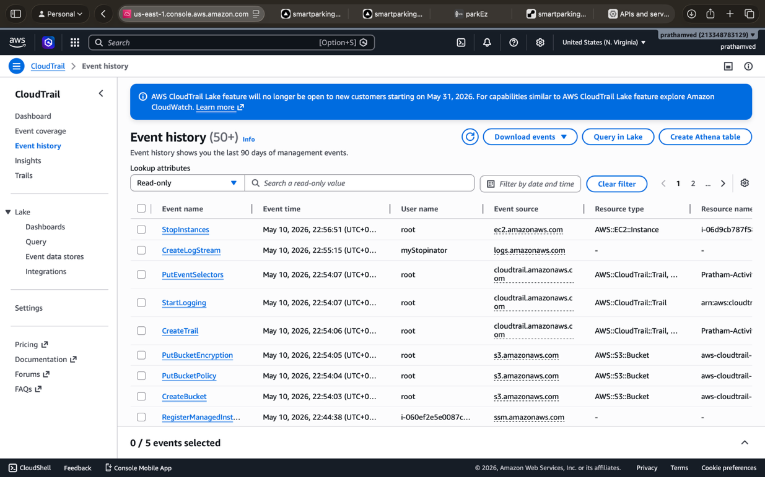
Checking S3 (Formal Storage):
- Go to your CloudTrail S3 bucket.
- Navigate deep into the folders: Region > Year > Month > Day.
- You will find .json.gz files. These are the raw logs containing the same data you saw in Event History.
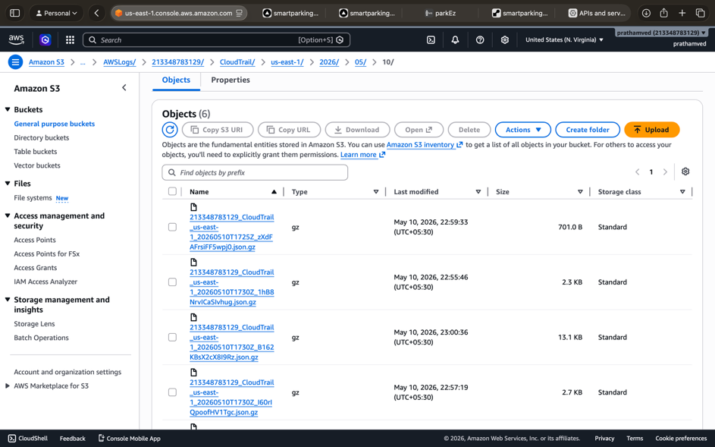

Q9 This solution provides a step-by-step guide to implementing Infrastructure as Code (IaC) using Terraform to provision an AWS EC2 instance.

Step 1: Install and Configure Terraform
- Install: Download the Terraform binary for your operating system (Windows/Linux/macOS) from the official website and add it to your system's PATH.
- Verify: Open your terminal and run terraform -v to ensure it is installed correctly.
- AWS CLI: Install the AWS CLI and run aws configure to set your Access Key, Secret Key, and Default Region so Terraform can authenticate with your account.

Step 2: Set Up the Working Directory
- Create a new folder for your project (e.g., ccl-terraform-lab).
- Open your terminal/command prompt and navigate into this directory.

Step 3: Create the Terraform Configuration
Create a file named main.tf in your directory and add the following code to define the provider, security group, and EC2 instance:
Terraform
# 1. Configure the AWS Provider
provider "aws" {
region = "us-east-1"
}

# 2. Create Security Group for SSH (22) and HTTP (80) [cite: 112]
resource "aws_security_group" "allow_web_ssh" {
name = "allow_web_ssh"
description = "Allow SSH and HTTP inbound traffic"

ingress {
from_port = 22
to_port = 22
protocol = "tcp"
cidr_blocks = ["0.0.0.0/0"] # For SSH access [cite: 112]
}

ingress {
from_port = 80
to_port = 80
protocol = "tcp"
cidr_blocks = ["0.0.0.0/0"] # For HTTP access [cite: 112]
}

egress {
from_port = 0
to_port = 0
protocol = "-1"
cidr_blocks = ["0.0.0.0/0"]
}
}

# 3. Launch Amazon EC2 Instance [cite: 110]
resource "aws_instance" "my_ec2" {
ami = "ami-0c55b159cbfafe1f0" # Amazon Linux 2 AMI [cite: 111]
instance_type = "t2.micro" # Free Tier type [cite: 111]
vpc_security_group_ids = [aws_security_group.allow_web_ssh.id]

tags = {
Name = "Terraform-Lab-Instance"
}
}

Step 4: Initialize and Provision
- Initialize: Run terraform init to download the necessary AWS provider plugins.
- Preview: Run terraform plan to see exactly what resources Terraform will create before making changes.
- Apply: Run terraform apply. Type yes when prompted to provision the resources on AWS.

Step 5: Verification and Validation
- Console Check: Log in to your AWS Management Console and navigate to EC2 > Instances to verify your instance is "Running".
- SSH Access: Use your terminal to connect to the instance: ssh -i "your-key.pem" ec2-user@<public-ip> to validate the deployment.

Step 6: Clean Up
- To avoid unwanted charges, run terraform destroy.
- Type yes to confirm the removal of the EC2 instance and the security group.

Q10

Complete Step-by-Step Guide for AWS Elastic Beanstalk (PaaS) Deployment
Follow these steps exactly to complete Task 11 of your practical exam.

1. Application Initialization
- Open Console: Navigate to Elastic Beanstalk in the AWS Management Console.
- Create App: Click Create application.
- Name: Enter CCL-PaaS-App.
- Environment Tier: Select Web server environment.
- Platform: Select Python (or Node.js/PHP) from the dropdown.
- Application Code: Select Sample application.
- Configuration: Choose Single instance (free tier eligible).

2. Service Access (IAM Roles)
- Service Role: Select aws-elasticbeanstalk-service-role from the dropdown.
- EC2 Instance Profile: Select aws-elasticbeanstalk-ec2-role from the dropdown.
Note: If these are missing, create them in the IAM console with the permissions AWSElasticBeanstalkWebTier and AWSElasticBeanstalkManagedUpdatesCustomerRolePolicy.
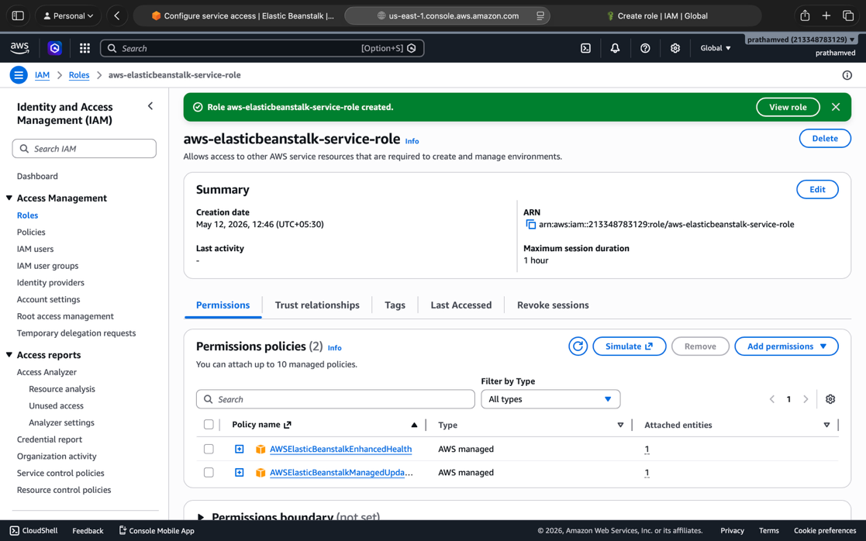
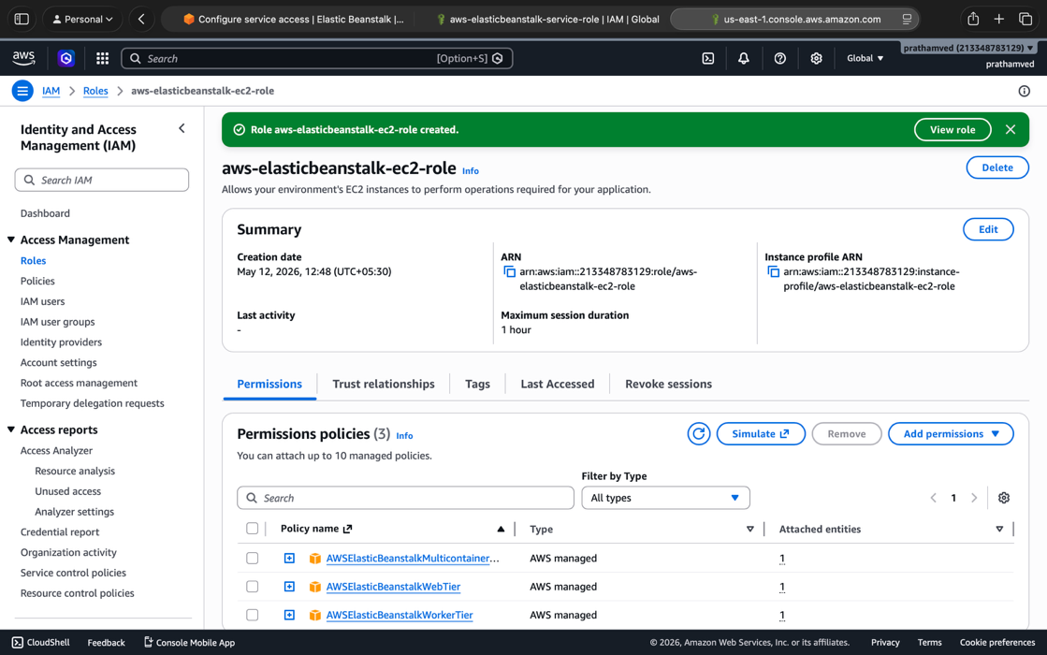
- EC2 Key Pair: Select your key (e.g., cal).

3. Networking and Subnets
- VPC: Select the Default VPC (172.31.0.0/16).
- Instance Subnets: Check the boxes for all available Availability Zones (e.g., us-east-1a, us-east-1b) to ensure successful provisioning.
- Public IP: Ensure Activated is checked so the instance is accessible via the internet.

4. Instance and Scaling
- Instance Type: Verify it is set to t2.micro (within Free Tier limits).
- Scaling: Keep as Single Instance for the lab to avoid unnecessary resource creation.

5. Deployment and Verification
- Review: Click Skip to Review and then click Submit.
- Wait: The process takes 3–5 minutes. Monitor the events log for "Environment health is Green".
- Access: Click the Domain URL at the top of the dashboard to open your live sample website.
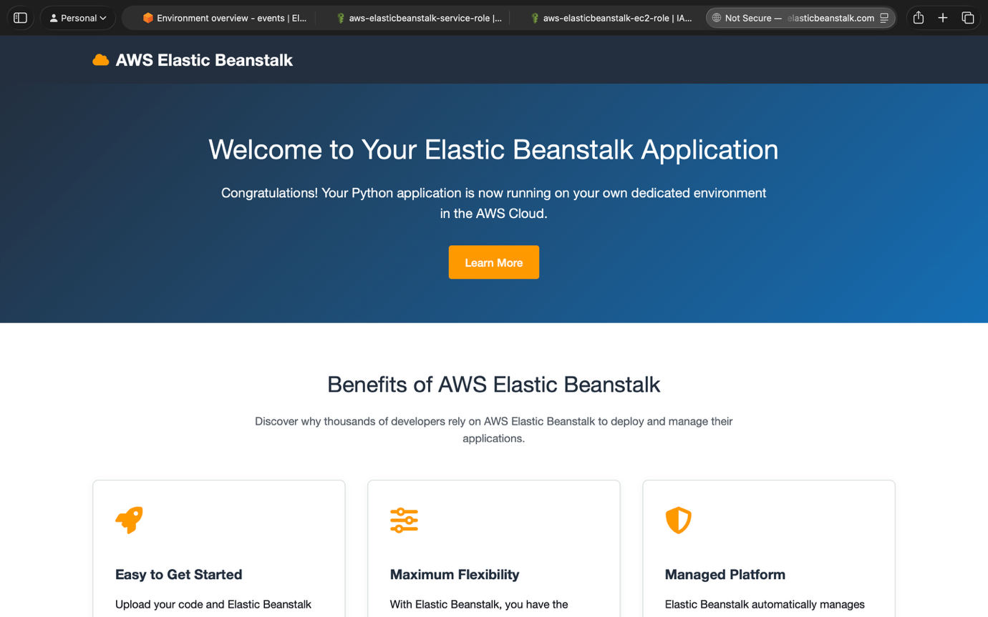

6. Post-Lab Management
- Health Check: Click the Health tab to show the examiner real-time status.
- Cleanup: Click Actions > Terminate Environment to delete all resources once you have finished your viva.
